**1. AWS SDK supports the following programming languages:**

* Java - AWS SDK for Java (versions 1.x and 2.x)
* Python - AWS SDK for Python (Boto3)
* JavaScript/TypeScript - AWS SDK for JavaScript (v2 and v3)
* .NET - AWS SDK for .NET
* C++ - AWS SDK for C++
* Go - AWS SDK for Go (v1 and v2)
* Ruby - AWS SDK for Ruby
* PHP - AWS SDK for PHP
* Rust - AWS SDK for Rust
* Kotlin - AWS SDK for Kotlin
* Swift - AWS SDK for Swift

**2. Regions where CloudShell is NOT supported:**

* China Regions (Beijing and Ningxia)
* AWS GovCloud (US-West) - Note: GovCloud (US-East) is supported

**3. AWS Infra Details**

AWS Regions: 38 geographic regions (with announced plans for 3 more in the Kingdom of Saudi Arabia, Chile, and the AWS European Sovereign Cloud)

Availability Zones: 120 Availability Zones across those regions (with announced plans for 10 more)

Edge Locations and CloudFront: 230+ Points of Presence, which includes:

* 218+ edge locations
* 12 regional edge cache locations

These Points of Presence serve 245 countries and regions across North America, South America, Europe, China, Asia Pacific, South Africa, and the Middle East.

Additional Infrastructure:

* 108 Direct Connect locations with connection speeds ranging from 50 Mbps to 100 Gbps

4. Default, we can only create 5 VPC per region – soft limit (can be increased by support)

5. For NACL, the maximum rule number is 32766. The rule with * is evaluated atlast

6. DNS Resolution in VPC  
  
 Here's a practical scenario example for DNS resolution in VPC peering:

Scenario: Multi-Account Application Architecture

Setup:

* VPC A (Account 1): Contains your web application servers
* VPC B (Account 2): Contains your database servers (Amazon RDS or EC2-hosted databases)
* Both VPCs are connected via VPC peering

Without DNS Resolution Enabled: When your web server in VPC A tries to connect to the database using its public DNS hostname db-server.us-east-1.compute.amazonaws.com:

* The hostname resolves to the database's public IP address (e.g., 54.123.45.67)
* Traffic goes out to the internet and back in through the Internet Gateway
* You pay internet data transfer rates ($0.09/GB out, $0.01/GB in)
* Higher latency and potential security concerns

With DNS Resolution Enabled:

When your web server queries the same hostname db-server.us-east-1.compute.amazonaws.com:

* The hostname resolves to the database's private IP address (e.g., 10.1.2.100)
* Traffic stays within AWS's private network via the peering connection
* You pay only $0.01/GB for peering data transfer (90% cost savings)
* Lower latency and better security

Event Processing:  
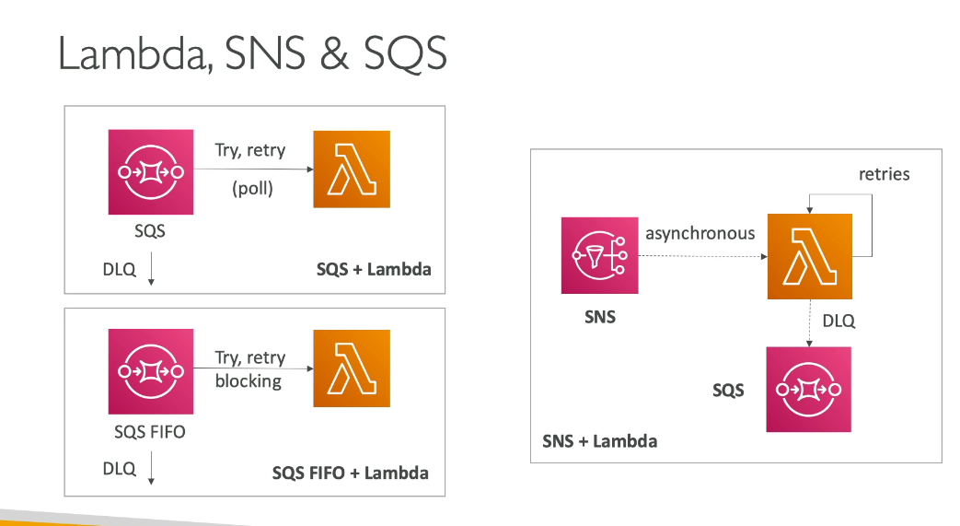DLQ – Dead Letter Queue

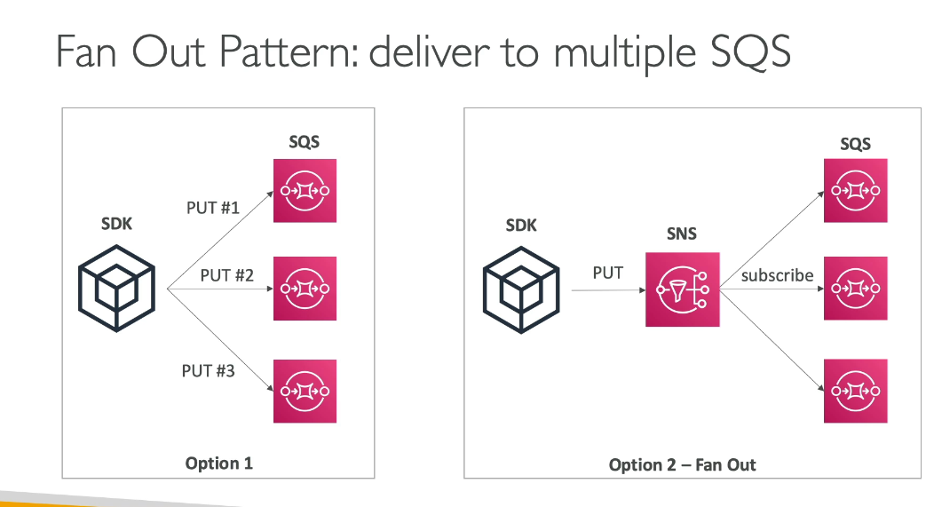

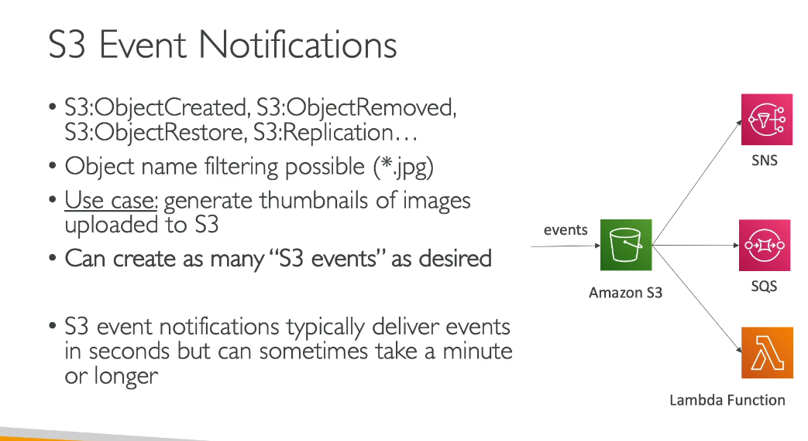

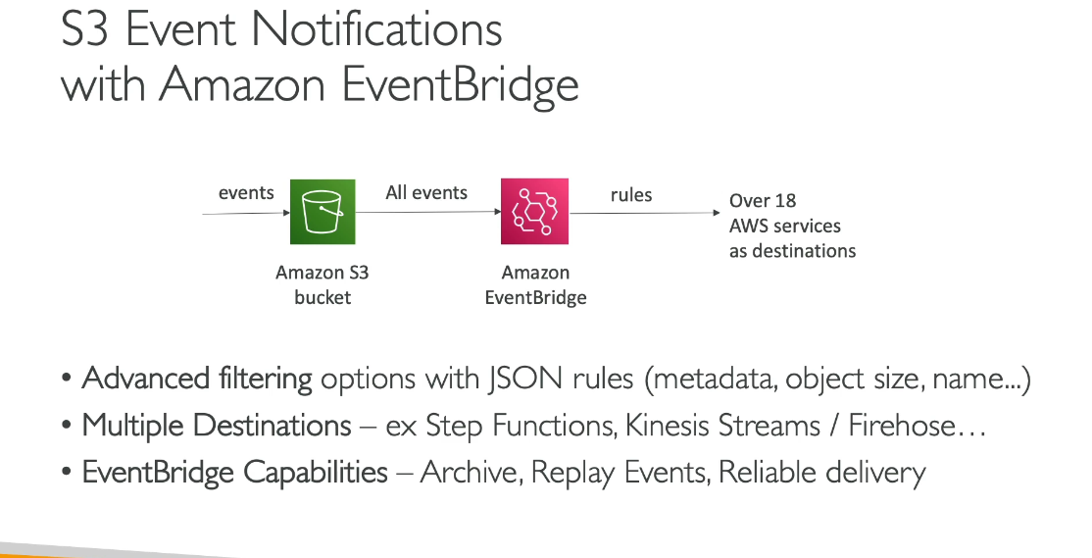

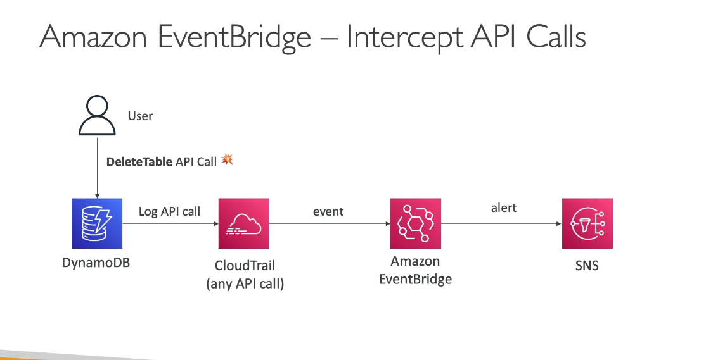

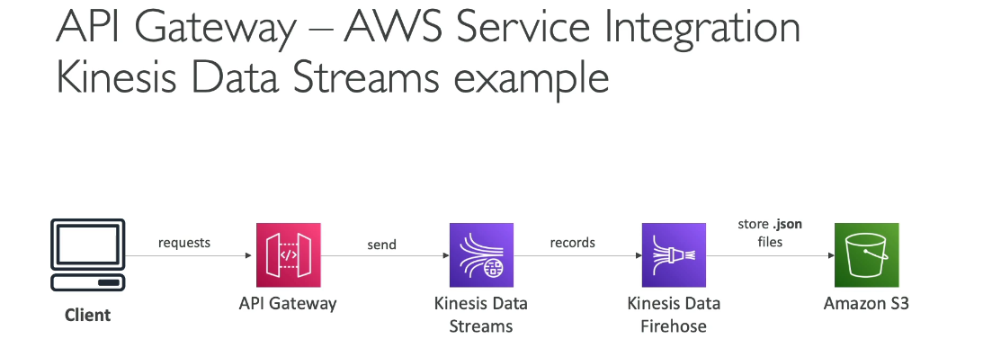

Caching Strategies:

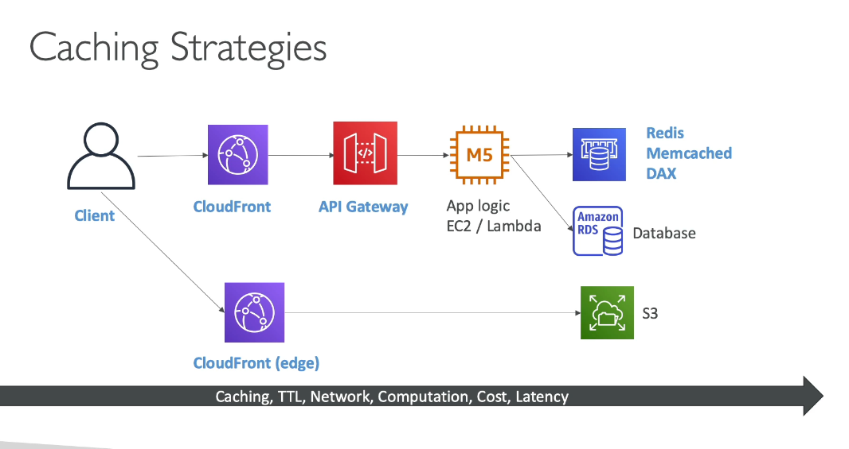

Blocking IP addresses:

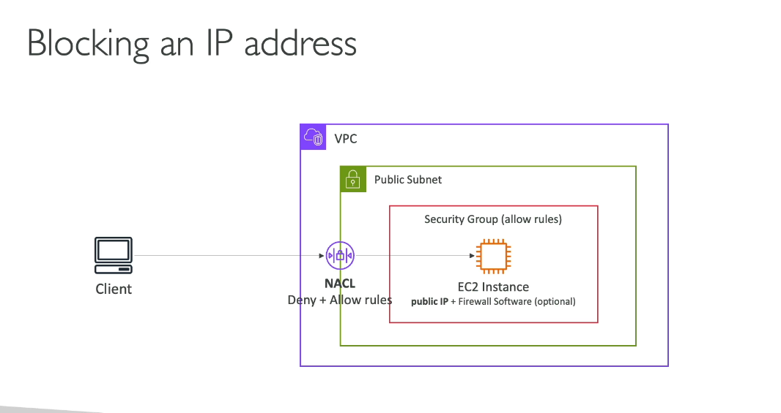

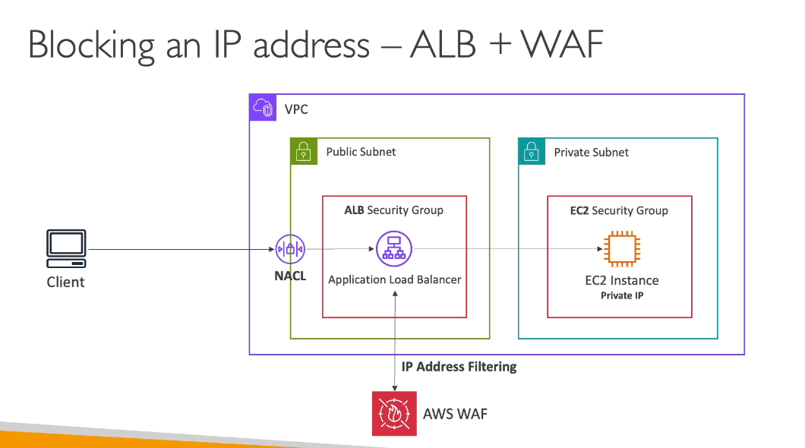

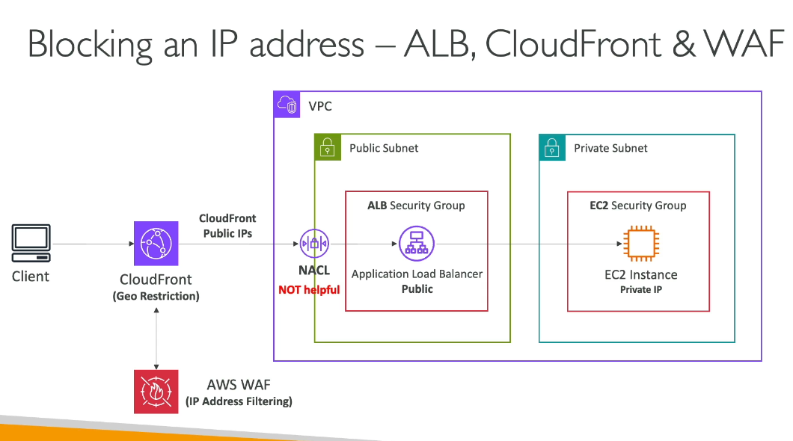

High Performance Computing:

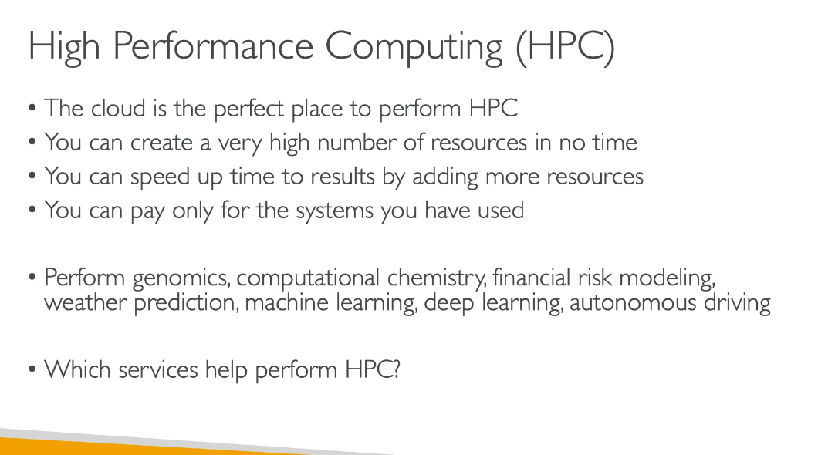

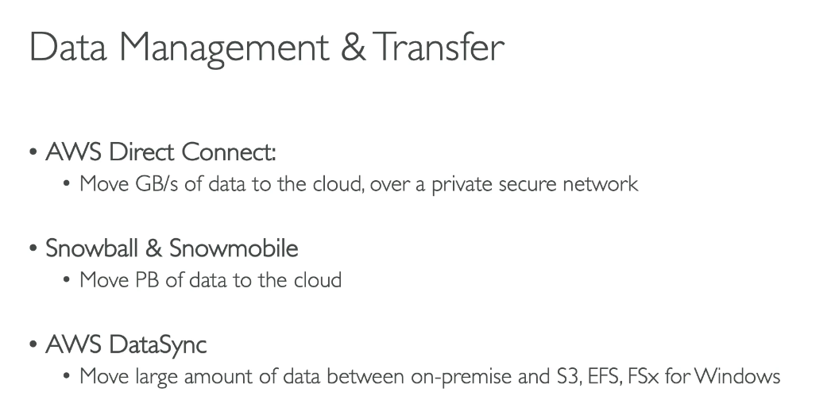

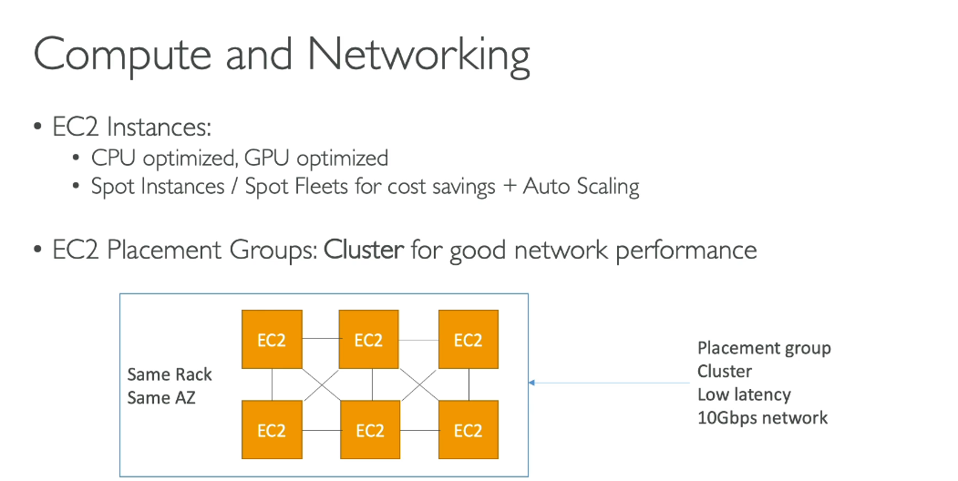

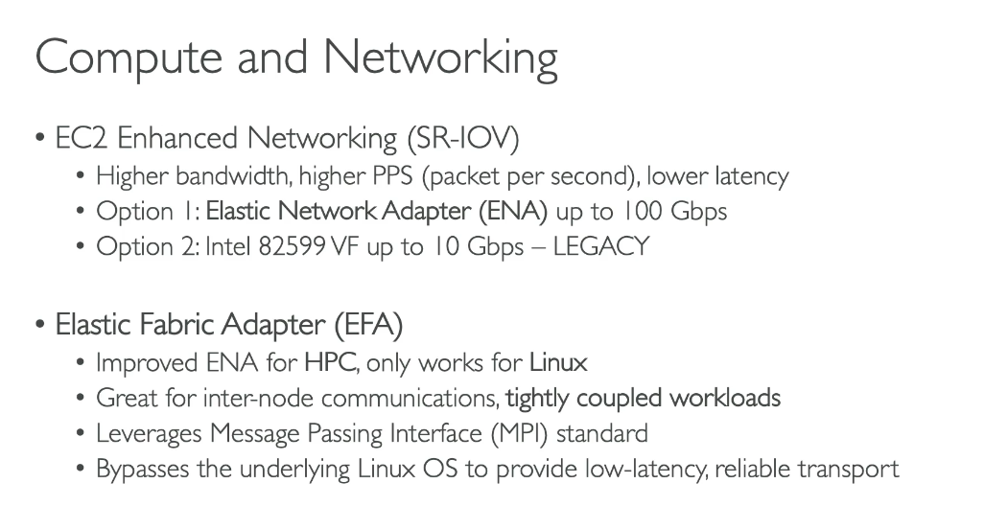

## **ENA (Elastic Network Adapter)**

**What it is**  
 ENA is AWS’s **default high-performance network interface** for EC2. It uses **SR-IOV** to bypass parts of the hypervisor and give instances fast, low-latency networking.

Think of ENA as: *“normal networking, but done properly.”*

### **Key characteristics**

* Up to **100 Gbps** bandwidth (instance-type dependent)
* High **PPS** (packets per second)
* Low latency
* Works on **Linux & Windows**
* Uses standard **TCP/UDP/IP stack**
* Default on all modern EC2 instance types

### **What ENA is not**

* Not HPC-specific
* Not MPI-aware
* Does **not** bypass the kernel networking stack

### **Typical use cases**

Use ENA for **almost everything** that isn’t hardcore HPC.

**Examples**

* Web applications (ALB → EC2)
* Microservices (EKS, ECS on EC2)
* Databases (RDS on EC2, self-managed DBs)
* Streaming, APIs, internal services
* Any workload where **TCP works fine**

👉 **Example scenario**  
 A fleet of c7g.4xlarge instances running microservices behind an ALB.  
 You want high throughput, low latency, and zero weird dependencies.  
 **ENA is the correct and only sane choice.**

## **EFA (Elastic Fabric Adapter)**

**What it is**  
 EFA is **not just “better ENA.”**  
 It’s a **specialized network interface for HPC** that enables **ultra-low latency, OS-bypassing communication** between instances.

Think of EFA as: *“Cluster interconnect, not general networking.”*

### **Key characteristics**

* Built **on top of ENA**, but heavily modified
* **Linux only**
* Designed for **HPC + tightly coupled workloads**
* Optimized for **MPI**
* Uses **libfabric**
* **Bypasses the Linux kernel network stack**
* Reliable, ordered delivery at very low latency

### **What EFA is not**

* Not for web apps
* Not for general TCP traffic
* Not for Windows
* Not useful unless your app is **MPI-aware**

### **Typical use cases**

Use EFA **only** when inter-node latency will kill you.

**Examples**

* Weather / climate modeling
* Computational fluid dynamics (CFD)
* Molecular dynamics
* Physics simulations
* Large-scale ML training (distributed GPU clusters)

👉 **Example scenario**  
 128 EC2 instances running an MPI-based simulation where every microsecond of inter-node latency matters.  
 TCP overhead would absolutely wreck performance.  
 **EFA is mandatory here.**

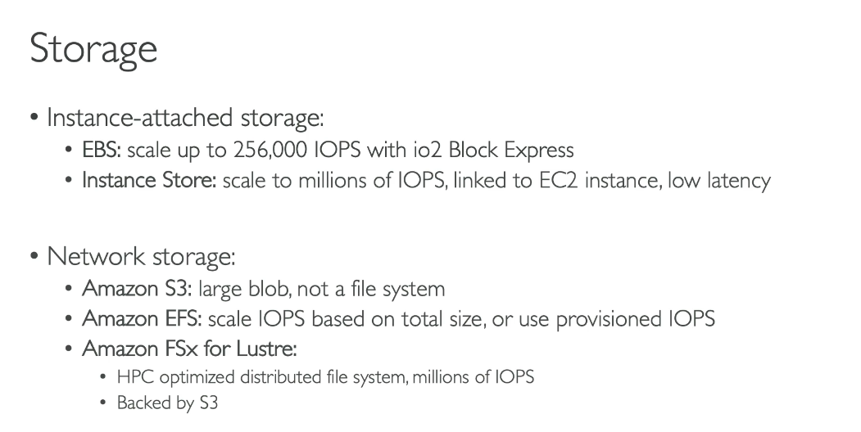

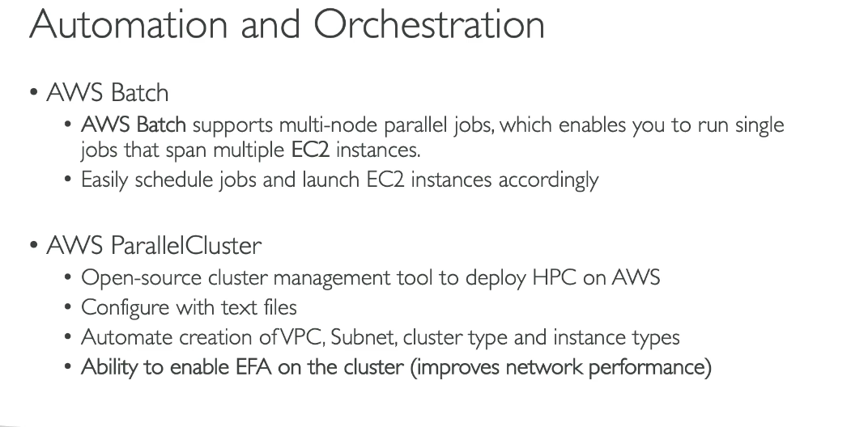

High Available EC2:

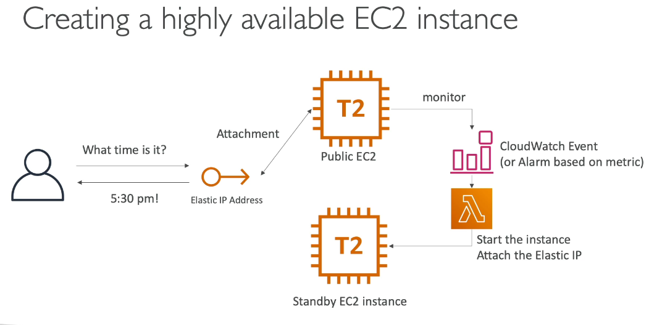

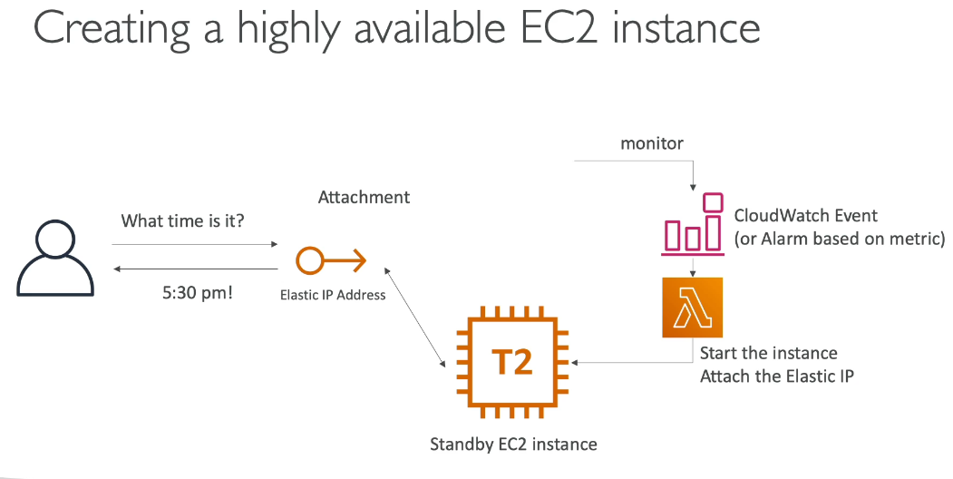

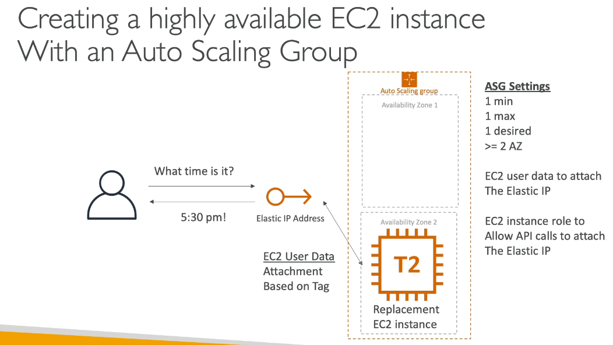

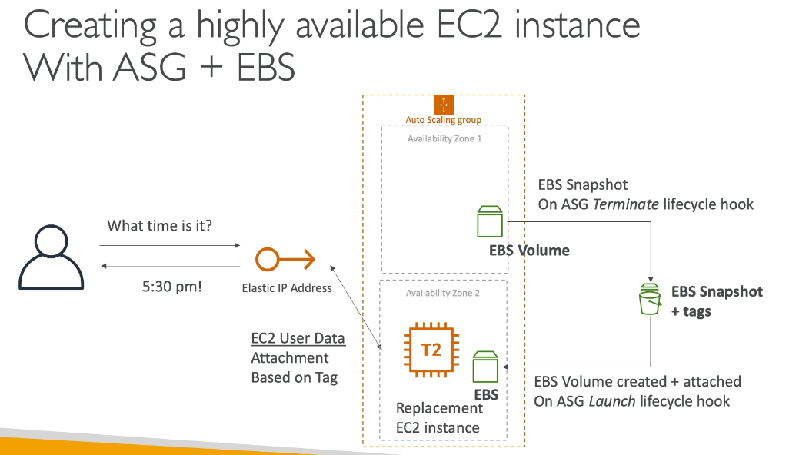

**AWS provides several migration strategies, commonly known as the "7 Rs of Migration":**

1. **Rehost** (Lift and Shift) Moving applications to AWS without modifications. Example: Moving your on-premises SQL Server database directly to an EC2 instance running SQL Server.

2. **Replatform** (Lift, Tinker, and Shift) Making minimal cloud optimizations without changing core architecture. Example: Migrating your on-premises MySQL database to Amazon RDS for MySQL instead of managing it on EC2.

3. **Repurchase** (Drop and Shop) Switching to a different product, typically SaaS. Example: Moving from an on-premises CRM system to Salesforce, or from self-managed email servers to Amazon WorkMail.

4. **Refactor/Re-architect** Reimagining how the application is built using cloud-native features. Example: Breaking down a monolithic application into microservices using AWS Lambda, API Gateway, and containers.

5. **Retire** Decommissioning applications that are no longer needed. Example: Identifying and shutting down redundant or unused applications during migration assessment.

6. **Retain** Keeping certain applications on-premises. Example: Applications with compliance requirements or those scheduled for future updates.

7. **Relocate** Moving infrastructure to AWS without modifications, typically for VMware workloads. Example: Using VMware Cloud on AWS to move existing VMware environments.

**Difference between Rehost and Relocate**

Rehost and Relocate are different migration strategies:

Rehost (Lift and Shift)

* Moves applications from on-premises to AWS Cloud
* Migrates individual servers/applications to AWS services like EC2
* Requires some configuration changes for cloud environment
* Example: Moving a physical server's workloads to an EC2 instance

Relocate

* Transfers infrastructure between environments with minimal changes
* Moves large numbers of servers at once to a cloud version of the same platform
* No need to reconfigure or modify the platform itself
* Example: Moving VMware SDDC to VMware Cloud on AWS, or transferring Amazon RDS instances between VPCs or AWS accounts

Key Difference: Rehost involves migrating from on-premises to cloud infrastructure (like EC2), while Relocate moves workloads between similar platforms or environments (like VMware to VMware Cloud on AWS) with direct transfer capabilities. Both strategies minimize application changes, but Relocate is more about platform-to-platform movement, whereas Rehost is about moving to cloud infrastructure.

**Here are the popular AWS Region codes and their names:**

North America:

* us-east-1 = US East (N. Virginia)
* us-east-2 = US East (Ohio)
* us-west-1 = US West (N. California)
* us-west-2 = US West (Oregon)
* ca-central-1 = Canada (Central)

Europe:

* eu-west-1 = Europe (Ireland)
* eu-west-2 = Europe (London)
* eu-central-1 = Europe (Frankfurt)
* eu-north-1 = Europe (Stockholm)
* eu-south-1 = Europe (Milan)

Asia Pacific:

* ap-south-1 = Asia Pacific (Mumbai)
* ap-northeast-1 = Asia Pacific (Tokyo)
* ap-northeast-2 = Asia Pacific (Seoul)
* ap-southeast-1 = Asia Pacific (Singapore)
* ap-southeast-2 = Asia Pacific (Sydney)
* ap-east-1 = Asia Pacific (Hong Kong)

Other Regions:

* sa-east-1 = South America (São Paulo)
* me-south-1 = Middle East (Bahrain)
* af-south-1 = Africa (Cape Town)

**Difference between AWS STS & AWS System manager session manager.**

**AWS STS (Security Token Service):**

AWS STS is a web service that enables you to request temporary, limited-privilege credentials for AWS Identity and Access Management (IAM) users or federated users. It provides:

* Temporary security credentials (access key ID, secret access key, and security token)
* Credentials that expire after a defined period (15 minutes to 36 hours)
* Enhanced security by eliminating the need for long-term credentials

**AWS Systems Manager Session Manager:**

Session Manager is a fully managed capability that lets you manage your EC2 instances, on-premises servers, and VMs through an interactive browser-based shell or AWS CLI, without needing to:

* Open inbound ports
* Maintain bastion hosts
* Manage SSH keys

**When to Use Together - Use Case:**

Scenario: A contractor needs temporary access to troubleshoot an application on EC2 instances in your production environment.

1. Use AWS STS to:
   1. Generate temporary credentials for the contractor
   2. Set credentials to expire after their work shift (e.g., 8 hours)
   3. Limit permissions to only what's needed
2. Use Session Manager to:
   1. Allow the contractor to connect to specific EC2 instances securely
   2. Audit all session activity through CloudWatch Logs
   3. Avoid exposing SSH ports or sharing long-term credentials This combination provides secure, auditable, time-limited access without compromising your infrastructure security.

**What is EBS FSR:**

EBS Fast Snapshot Restore (FSR) is a feature that enables you to create EBS volumes from snapshots that are fully initialized at creation. This eliminates the latency of I/O operations when a block is accessed for the first time, allowing volumes to instantly deliver all their provisioned performance without needing initialization.

Key Benefits:

* Faster boot times for EC2 instances
* Improved performance for Auto Scaling Groups
* Ideal for VDI environments and applications using large/custom AMIs

How to Enable FSR:

1. Enable FSR on a Snapshot:
   1. Go to EC2 Console → Snapshots
   2. Select your snapshot
   3. Click Actions → Manage Fast Snapshot Restore
   4. Select the Availability Zones where you want to enable FSR
   5. Click Enable
2. Use with Auto Scaling Group:
   1. Create or update your Launch Template/Configuration to use an AMI built from the FSR-enabled snapshot
   2. When Auto Scaling launches instances, volumes created from the FSR-enabled snapshot will have full performance immediately
   3. This allows your Auto Scaling Group to come online and start processing traffic more quickly

Important Notes:

* FSR must be enabled per Availability Zone
* Volume creation is limited by a credit-based system
* Additional charges apply for FSR

**AWS Secrets Manager and AWS Systems Manager Parameter Store** are both used to store sensitive data, but they serve different purposes:

**AWS Secrets Manager:**

* Specifically designed for managing secrets like database credentials, API keys, and OAuth tokens
* Automatic rotation: Built-in capability to automatically rotate secrets on a schedule
* Native integration with RDS databases (MySQL, PostgreSQL, Aurora)
* Custom rotation using Lambda functions for other secret types
* Higher cost but more features for secret lifecycle management

**Systems Manager Parameter Store:**

* General-purpose hierarchical storage for configuration data and secrets
* Stores data like AMI IDs, license codes, passwords, and database strings
* No automatic rotation: You must manually update parameters
* Lower cost (free tier available for standard parameters)
* Can reference Secrets Manager secrets, allowing you to use secrets stored in Secrets Manager through Parameter Store

**When to Use:**

* Secrets Manager: When you need automatic rotation, managing database credentials, or full secret lifecycle management
* Parameter Store: For configuration data, static secrets that don't need rotation, or when cost is a concern

Integration: You can store secrets in Secrets Manager and reference them from Parameter Store, combining the rotation capabilities of Secrets Manager with Parameter Store's integration with other AWS services.

**Difference between S3 and FSx File Gateway:**

**Amazon S3 File Gateway:**

* Stores files as objects in Amazon S3
* Provides NFS or SMB access to S3 buckets
* Optimized for large files and scale-out workloads
* Best for: Database backups, archives, data lakes, machine-generated data, and ingesting vast amounts of data into S3
* Can contain billions of objects

**Amazon FSx File Gateway:**

* Provides low-latency, on-premises access to Amazon FSx for Windows File Server
* Optimized for small and mixed file size workloads
* Best for: Multi-user interactive file sharing, departmental shares, home directories, and end-user applications like Microsoft Office
* Supports complex Windows features like permissions, data deduplication, and DFS Namespaces

**In which are the plan, is it possible to change the EC2 instance family?**

You can change EC2 instance families in the following plans:

1. Compute Savings Plans:

* Provides the most flexibility to change instance families
* You can switch between any instance family (e.g., C4 to M5, M6i to C5)
* Works across any Region, OS, tenancy, and even applies to Fargate and Lambda
* Offers up to 66% savings

2. EC2 Instance Savings Plans:

* Cannot change instance families - locked to a specific instance family within a Region
* You can only change instance sizes within the same family (e.g., c5.xlarge to c5.2xlarge)
* Can change OS (Windows to Linux) and tenancy within the same family
* Offers up to 72% savings (highest discount)

3. Reserved Instances (RIs):

* Standard RIs: Cannot change instance family
* Convertible RIs: Can change instance family, but with some restrictions and potentially lower discount rates
* Can modify Linux/UNIX RIs within the same instance family

Summary: Only Compute Savings Plans offer full flexibility to change between different instance families. EC2 Instance Savings Plans and Standard RIs lock you to a specific instance family.

**Compute Savings Plans apply to the following AWS services:**

1. Amazon EC2:

* All instance families (M5, C5, R5, etc.)
* All instance sizes
* All Regions
* All operating systems (Linux, Windows, etc.)
* All tenancy types (Dedicated, default, Dedicated Host)

2. AWS Fargate:

* Container workloads running on Fargate

3. AWS Lambda:

* Serverless function compute usage

**For the AWS Batch service, dont we need to choose the ec2 instance type?**

No, you don't necessarily need to choose a specific EC2 instance type for AWS Batch. AWS Batch offers flexible options:

Automatic Instance Selection:

You can let AWS Batch automatically select the best instance types by choosing:

* optimal: Selects from C4, M4, R4, C5, M5, and R5 instance families (Note: Starting 11/01/2025, this will behave like default_x86_64)
* default_x86_64: Chooses x86-based instances (M6i, C6i, R6i, C7i) that match your job queue demands
* default_arm64: Chooses ARM-based instances (M6g, C6g, R6g, C7g) that match your job queue demands

Manual Instance Selection:

You can also specify exact instance types if needed:

* Specific instance families (e.g., c5, p3)
* Specific instance sizes (e.g., c5.8xlarge)

How It Works: When you create a Compute Environment, you set parameters like minimum, desired, and maximum vCPUs. AWS Batch then efficiently launches, manages, and terminates instances based on your job queue demands and the instance type selection you've configured. This flexibility allows you to optimize for cost and performance without manually managing instance selection.

**Difference between DynamoDB and Aurora**

Both Amazon Aurora and Amazon DynamoDB are highly scalable and highly available, but they excel in different ways:

Amazon Aurora:

* Provides high availability with a distributed architecture that replicates storage across 3 Availability Zones
* Offers automatic failover with no data loss
* Scales storage automatically up to 128 TB
* Supports up to 15 read replicas for read scaling
* Designed for relational database workloads with MySQL and PostgreSQL compatibility

Amazon DynamoDB:

* Delivers single-digit millisecond performance at any scale
* Handles more than 10 trillion requests per day and peaks of 20+ million requests per second
* Fully managed, serverless with automatic scaling
* Multi-Region replication with built-in high availability
* Designed for key-value and document database workloads

Verdict: DynamoDB offers greater scalability for massive throughput requirements and is inherently more scalable due to its NoSQL architecture. Both provide excellent high availability, but DynamoDB's serverless nature and ability to handle trillions of requests makes it the more scalable option for internet-scale applications.

Choose based on your workload: Aurora for relational data with ACID compliance, DynamoDB for extreme scale and performance.

**Key Lambda limits**:

**Memory Configuration:**

* You can configure memory between 128 MB and 10,240 MB (10 GB) in 1-MB increments
* CPU power is allocated proportionally to the memory configured

**Storage** Limits:

* Deployment package size: 50 MB (zipped, direct upload) or 250 MB (unzipped, including layers)
* Container image size: 10 GB
* /tmp directory storage: 512 MB to 10,240 MB (configurable)

**Concurrent Executions:**

* Default quota: 1,000 concurrent executions per region
* This can be increased to tens of thousands by requesting a quota increase

**Multi-AZ DB Cluster** is the latest deployment option for Amazon RDS PostgreSQL (and MySQL), offering enhanced performance and availability compared to traditional Multi-AZ deployments.

Key Features:

* Architecture - Consists of one primary (writer) DB instance and two readable standby instances, each in a separate Availability Zone
* Read Capability - Unlike traditional Multi-AZ where the standby is not accessible, both standby instances in a Multi-AZ DB cluster can serve read traffic
* Performance - Provides up to 2x faster commit latencies with semi-synchronous replication
* Faster Failover - Automated failover typically completes in under 35 seconds (compared to longer times in traditional Multi-AZ)
* Storage - Uses fast NVMe SSD for local storage, ideal for high-speed, low-latency operations

Traffic Distribution:

* Write traffic goes to the cluster endpoint (primary instance)
* Read traffic can be distributed to the reader endpoint (standby instances)

**Multi-AZ DB cluster deployment is not available for all RDS database engines. It is currently supported only for:**

* Amazon RDS for MySQL (version 8.0.26 and higher)
* Amazon RDS for PostgreSQL (version 13.4 and higher)

**AWS DataSync Size and Throughput limits**  
**AWS DataSync** has limits on the number of files, objects, and directories it can handle per task execution, but not on the total amount of data transferred:

Enhanced Mode Tasks:

* Virtually unlimited number of source and destination objects per task execution

Basic Mode Tasks:

* Between on-premises/self-managed storage and AWS: 50 million files, objects, and directories
* Between AWS storage services: 25 million files, objects, and directories

Important Notes:

* If transferring Amazon S3 objects with prefixes, the prefixes count as directories (e.g., s3://bucket/foo/bar.txt counts as 2 directories and 1 object)
* For tasks with more than 20 million files, allocate at least 64 GB of RAM to your DataSync agent

Throughput Limits:

* With DataSync agent: 10 Gbps per task
* Without DataSync agent (AWS-to-AWS transfers): 5 Gbps per task

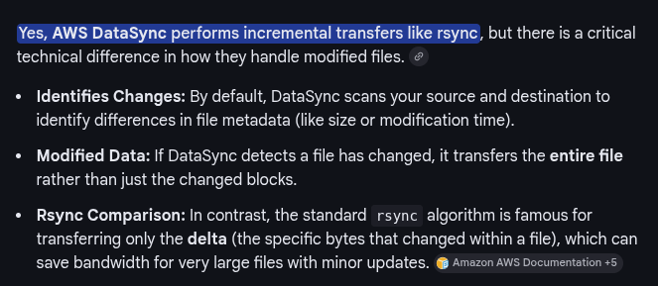

|  |  |  |
| --- | --- | --- |
| **Connection type** | **AWS side** | **On-prem side** |
| Site-to-Site VPN | VGW or TGW | **Customer Gateway** |
| Direct Connect | VGW or TGW | **DX router (physical)** |

VGW – Virtual private gateway.

TGW – Transit gateway

**AWS X-Ray** is a distributed tracing service that helps you analyze and debug distributed applications. It provides end-to-end visibility into your application's performance and behavior.

Key Uses:

* Trace request execution - Visualize the complete flow of requests through your application, including latencies, errors, and performance bottlenecks
* Identify performance issues - Pinpoint the root cause of problems by analyzing the execution path of requests, including downstream calls to AWS services, APIs, and databases
* Monitor error rates - Track and receive alerts on application errors with detailed error messages and stack traces
* Service map visualization - Generate a detailed map showing relationships between resources and services in your application

How It Works:

* Collects data from your application and integrated AWS services
* Records traces by combining data from each service into unified units
* Supports applications running on Amazon EC2, Amazon ECS, AWS Lambda, AWS Elastic Beanstalk, and more

Benefits:

* Helps developers quickly identify unusual behavior and drill down into specific services affecting performance
* Enables real-time monitoring and utilization tracking
* Integrates seamlessly with other AWS services for comprehensive application monitoring

**Amazon AppFlow** is a fully managed integration service that enables you to securely transfer data between Software as a Service (SaaS) applications and AWS services.

Key Uses:

* Data integration - Connect SaaS applications like Salesforce, Marketo, Slack, ServiceNow, and Zendesk with AWS services like Amazon S3 and Amazon Redshift
* Automated data flows - Create data flows in minutes without writing code
* Data synchronization - Run flows on-demand or on a schedule to keep data in sync across applications
* Data aggregation - Combine data from multiple sources for analytics and reporting

How It Works:

* Set up secure connections to your SaaS applications
* Configure data flows to specify source, destination, and transformation rules
* Schedule flows or trigger them on-demand
* Data is transferred securely with encryption

Benefits:

* Quick setup - Create data flows in minutes without coding
* Secure transfers - Built-in encryption and security features
* Cost-effective - Pay only for what you use, no infrastructure to manage
* Bidirectional - Supports data transfer both to and from SaaS applications

Example Use Cases:

* Ingest contact records from Salesforce to Amazon Redshift for analytics
* Pull support tickets from Zendesk to Amazon S3 for archival
* Sync customer data between multiple applications

**AWS Network Firewall and AWS Firewall Manager** serve different but complementary purposes:

AWS Network Firewall:

* Purpose: A managed network security service that provides traffic filtering for your VPCs
* Function: Acts as the actual firewall that inspects and filters network traffic
* Key Features:
  + Deploys firewall endpoints in VPC subnets
  + Supports thousands of rules based on domain, port, protocol, IP address, or pattern matching
  + Uses Suricata-compatible rules
  + Provides stateful and stateless inspection
  + Scales automatically with network traffic
* Use Case: Protecting individual VPCs with customizable firewall rules

AWS Firewall Manager:

* Purpose: A centralized security management service for multiple accounts and resources
* Function: Manages and deploys firewall policies across your AWS organization
* Key Features:
  + Central configuration and deployment of firewall rules
  + Works across AWS Regions, accounts, and resources in AWS Organizations
  + Ensures consistent policy enforcement
  + Automatically applies policies to new accounts and resources
  + Integrates with Network Firewall, WAF, Shield Advanced, and VPC security groups
* Use Case: Centrally managing security policies across multiple accounts

Key Difference:

* Network Firewall = The firewall itself (does the filtering)
* Firewall Manager = The management tool (deploys and manages firewalls) They work together: Firewall Manager can centrally deploy and manage Network Firewall rules across your organization.

**Throttling in API Gateway:**

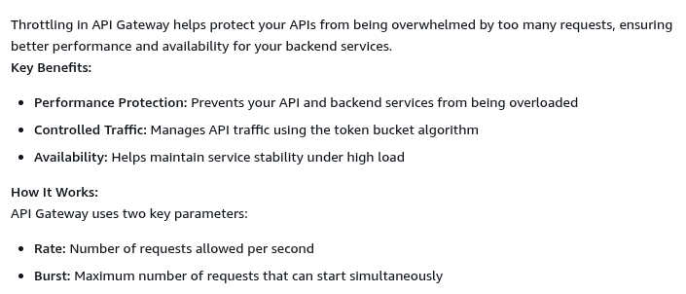

**AWS CloudHSM** is a managed service that provides secure cryptographic key storage and operations within a tamper-resistant hardware device. It offers single-tenant Hardware Security Modules (HSMs) in the AWS Cloud.

What It Does:

CloudHSM securely stores cryptographic key material and performs cryptographic operations without exposing the keys outside the cryptographic boundary of the appliance.

Key Features:

* Scalable HSM capacity: Add and remove HSMs on-demand using the AWS Management Console and AWS API
* Single-tenant access: Dedicated HSM instances for enhanced security and control
* Industry-standard APIs: Integration with custom applications via standard APIs and multiple programming languages
* Open solution: Transfer keys to other commercial HSM solutions, avoiding vendor lock-in
* Secure authentication: Supports quorum authentication and multi-factor authentication (MFA)
* AWS-managed infrastructure: Automates hardware provisioning, software patching, high availability, and backups

**Amazon WorkDocs** is a secure, fully managed file collaboration and management service that enables users to create, store, and share content from anywhere on any device.

Key Features:

* Secure file storage: Centralized repository for your documents with enterprise-grade security
* File collaboration: Share files and collaborate with team members in real-time
* Access from anywhere: Available on multiple devices including web, desktop, and mobile
* Content management: Organize, manage, and track document versions
* Integration capabilities: Extensible SDK for developing custom applications

Common Use Cases:

* Team collaboration: Share and collaboratively edit Microsoft Office files (Word, Excel, PowerPoint)
* Document management: Store and organize business documents securely
* Mobile access: Access your cloud content directly from iOS devices and other platforms
* Custom applications: Use the WorkDocs API with AWS SDK to build automated document processing workflows

**AWS Resource Access Manager** (AWS RAM) is a service that helps you securely share your AWS resources across AWS accounts, within your organization, or with specific accounts, eliminating the need to provision duplicate resources in multiple accounts.

Key Features:

* Cross-account sharing: Share resources with any AWS account or within your AWS Organizations
* Organizational unit (OU) support: Share with all accounts in your organization or specific OUs
* Centralized management: Create resources once and share them across multiple accounts
* No additional cost: Available at no extra charge

Shareable Resources Include:

* VPC subnets
* Transit Gateway connections
* AWS License Manager configurations
* Amazon Route 53 Resolver rules
* Amazon Aurora DB clusters (in most regions)
* And many other AWS resources

**Difference between AWS Organizations & AWS Control Tower:**

AWS Organizations:

* Account management service that consolidates multiple AWS accounts into a centrally managed organization
* Provides basic account grouping and policy management capabilities
* Enables consolidated billing across all member accounts
* Allows you to apply Service Control Policies (SCPs) to control permissions
* Foundation service for multi-account management

AWS Control Tower:

* Built on top of AWS Organizations to provide automated setup and governance
* Offers a simplified way to set up and govern a secure, multi-account AWS environment
* Provides a landing zone with pre-configured best practices
* Includes preventive and detective controls (guardrails) automatically
* Integrates with AWS Service Catalog and AWS Single Sign-On (SSO)
* Features Account Factory for automated account provisioning with pre-approved baselines

**AWS Cost and Usage Reports** (AWS **CUR**) is the most comprehensive source of information about your AWS costs and usage. Here's what it's used for:

Key Uses:

* Detailed cost tracking - Breaks down your costs by hour, day, or month, by product, product resource, or custom tags you define
* Usage analysis - Tracks your AWS usage across all services and provides estimated charges for each unique combination of AWS products, usage type, and operation
* Calculate savings - Shows both the discounted rate charged and the public On-Demand rate, allowing you to quantify your savings (especially with Reserved Instances)
* Track Reserved Instance benefits - Each line item shows which instances are benefiting from specific reservations
* Cost allocation - Helps you understand where your AWS spending is going and identify cost optimization opportunities

How to Access:

The reports are published to an Amazon S3 bucket you own in CSV format, updated once daily. You can analyze them using spreadsheet software, or integrate with Amazon Athena, Amazon Redshift, or Amazon QuickSight for deeper analysis.

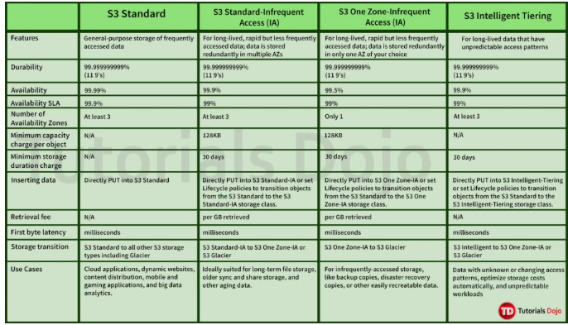

**Amazon Simple Workflow Service** (Amazon SWF) is a web service that makes it easy to coordinate work across distributed application components.

What It Does:

* Coordinates tasks - Helps you design applications as a coordination of tasks, where tasks can be executable code, web service calls, human actions, or scripts
* Manages workflow execution - Handles execution dependencies, scheduling, and concurrency according to your application's logical flow
* Tracks state automatically - Manages tracking progress and maintaining state so you don't have to worry about these complexities

Common Use Cases:

* Media processing
* Web application back-ends
* Business process workflows
* Analytics pipelines

Key Benefits:

* Logical separation - Separates control flow logic from your core business logic, making it easier to manage and scale
* Full control - Gives you complete control over implementing tasks and coordinating them
* Simplified development - Includes the AWS Flow Framework to help with asynchronous programming

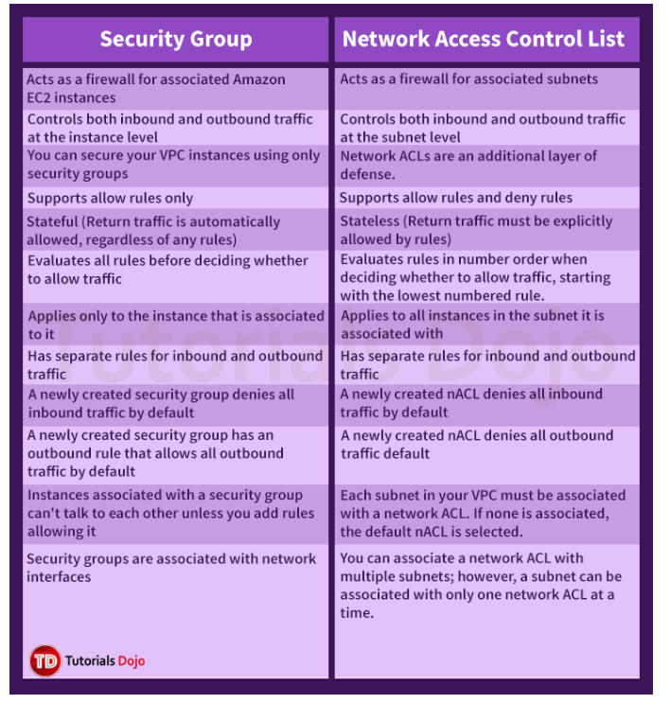

DynamoDB  
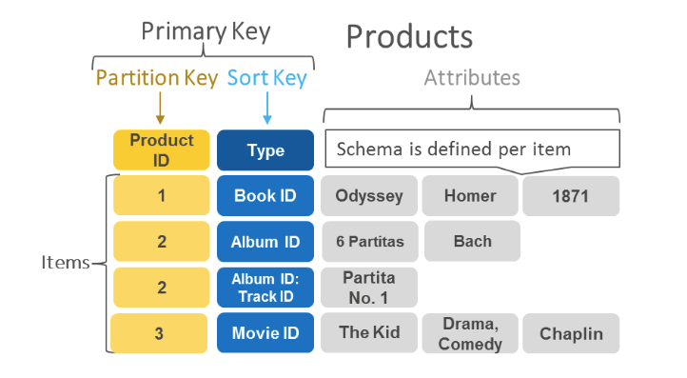

**Here are AWS services that can and cannot directly move data into S3 Glacier storage classes:**

Services That CAN Directly Move Data to S3 Glacier:

* AWS DataSync - Transfers data from on-premises or other cloud storage directly to S3 Glacier storage classes
* AWS Storage Gateway - File Gateway and Volume Gateway can write directly to S3 with Glacier storage classes
* AWS Transfer Family - Can upload files directly to S3 buckets configured with Glacier storage classes
* AWS Snow Family (Snowball, Snowcone) - Can transfer data to S3 with Glacier as the destination storage class
* S3 Batch Operations - Can copy objects directly to Glacier storage classes
* Amazon S3 APIs/SDKs - You can PUT objects directly to Glacier storage classes programmatically

Services That CANNOT Directly Write to S3 Glacier:

* Amazon Kinesis Data Firehose - Cannot deliver data directly to Glacier storage classes; delivers to S3 Standard, then you must use S3 Lifecycle policies to transition
* AWS Database Migration Service (DMS) - Writes to S3 Standard only; requires Lifecycle policies for Glacier transition
* Amazon EMR (prior to version 7.2) - Could not directly read/write to Glacier storage classes

**Signed URLs and presigned URLs** are related but have distinct differences:

Signed URLs:

* Generic term for any URL that includes authentication information (signature) to verify the request
* The signature is calculated using AWS credentials and request parameters
* Used across various AWS services for authenticated requests
* Signature can be included in query parameters or headers

Presigned URLs:

* A specific type of signed URL that grants temporary access to a specific resource
* Generated by someone with valid AWS credentials to allow others (who may not have AWS credentials) to perform specific actions
* Include an expiration time (X-Amz-Expires parameter) - typically 15 minutes by default, but customizable
* Act as bearer tokens - anyone with the URL can access the resource until it expires
* Commonly used with Amazon S3 to allow temporary upload or download access

Enable **Amazon Aurora Parallel Query**, this feature simply enables Amazon Aurora to push down and distribute the computational load of a single query across thousands of CPUs in Aurora's storage layer. Take note that it does not load balance all of the incoming read requests equally to the two Read Replicas. With Parallel Query, query processing is pushed down to the Aurora storage layer. The query gains a large amount of computing power, and it needs to transfer far less data over the network. In the meantime, the Aurora database instance can continue serving transactions with much less interruption. This way, you can run transactional and analytical workloads alongside each other in the same Aurora database, while maintaining high performance.

An **Elastic Fabric Adapter (EFA)** is a network device that you can attach to your Amazon EC2 instance to accelerate High-Performance Computing (HPC) and machine learning applications.

**Billing of EC2 instances in different states:**

According to AWS documentation, compute billing begins when the instance enters the running state for all three purchasing options: On-Demand, Reserved Instances, and Spot Instances.

Instance State Billing Details:

* pending state - Not billed (the instance is preparing to enter the running state)
* running state - Billed for all purchasing options (charged per second with a one-minute minimum)
* stopping state - Not billed (except if you hibernate an instance)
* stopped state - Not billed for compute (though EBS volume storage charges still apply)
* shutting-down state - Not billed
* terminated state - Not billed

Important Note for Reserved Instances:

While compute billing for Reserved Instances also starts in the running state, you are charged for the entire Reserved Instance term regardless of whether the instance is running or not. If you terminate an instance with an active Reserved Instance, you continue to be billed for the Reserved Instance until the end of its term according to the payment option you selected.

Summary: For all three purchasing options, you only pay for compute when instances are in the running state, not during the pending state.

### **1️⃣ AWS Personal Health Dashboard (PHD) ✅**

**Account-specific. Actionable. What you need here.**

**What it shows**

* Events that affect **YOUR AWS account**
* Specific to **your EC2 instances, your AZs, your resources**
* Includes:
  + Scheduled maintenance
  + Instance retirement
  + Hardware degradation
  + Power events
  + Network issues impacting *your* instances

**Key properties**

* Per-account
* Per-resource
* EventBridge-integrated
* Designed for **notifications and automation**

**This is why it’s the correct answer.**

### **2️⃣ AWS Service Health Dashboard (SHD) ❌**

**Public. Generic. Mostly useless for this requirement.**

**What it shows**

* Global / regional AWS service outages
* Same info visible to **everyone**
* No account or resource context

Example:

“EC2 in ap-south-1 is experiencing elevated API latency”

**What it does NOT show**

* ❌ Which of *your* instances are affected
* ❌ Upcoming maintenance for your EC2
* ❌ Instance retirement warnings

**You cannot rely on this for mission-critical instance alerts.**

S3 Data transfer out cost wont apply for the below.

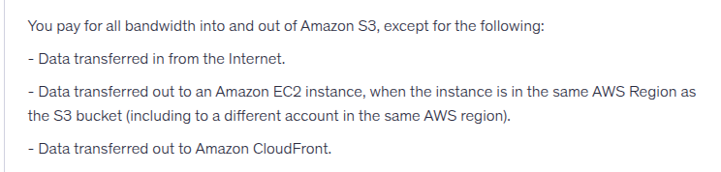

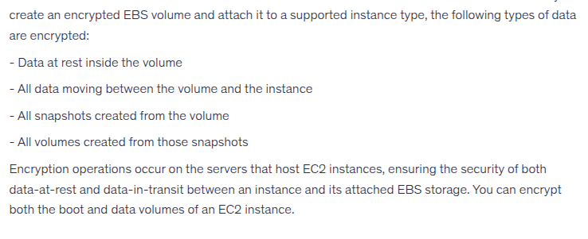

**AWS AppSync** is a fully managed serverless GraphQL service that simplifies application development by enabling you to create flexible APIs to securely access, manipulate, and combine data from multiple sources.

Key features:

* GraphQL API management - Provides a consistent programming language for applications and devices to connect to services
* Real-time and offline capabilities - Supports real-time data synchronization and offline functionality
* **Multiple data source integration - Connects to services like DynamoDB, OpenSearch Service, and Amazon S3**
* Enterprise-grade security - Includes built-in security controls following AWS best practices
* Serverless and scalable - Automatically scales based on demand without infrastructure management

AppSync is ideal for building data-driven mobile and web applications with a serverless backend, allowing developers to focus on application logic rather than infrastructure management.

**Amazon WorkSpaces** is a fully managed, secure Desktop-as-a-Service (DaaS) solution that provides cloud-based virtual desktops for your users.

Key uses and benefits:

* Remote workforce enablement - Provides employees, contractors, and third-party vendors with secure access to corporate applications and resources from anywhere, on any supported device
* Quick deployment - Provision Windows or Linux desktops in minutes and scale to thousands of users globally
* Cost-effective - Pay monthly or hourly only for the WorkSpaces you use, eliminating traditional desktop and VDI infrastructure costs
* Simplified management - Removes complexity of managing hardware inventory, OS versions, patches, and Virtual Desktop Infrastructure (VDI)
* Fast, responsive experience - Users get a desktop they can access anytime, anywhere, from any supported device

Common use cases:

* Educational institutions providing students access to applications for class
* Software vendors delivering trials, demos, and training without downloads
* Companies supporting remote and hybrid work environments WorkSpaces helps organizations provide secure, flexible desktop access while reducing IT overhead and infrastructure costs.

## **Redis vs Memcached (AWS / ElastiCache context)**

|  |  |  |
| --- | --- | --- |
| **Feature / Aspect** | **Redis (ElastiCache for Redis)** | **Memcached (ElastiCache for Memcached)** |
| Data model | **Rich data structures** (strings, hashes, lists, sets, sorted sets, streams) | **Simple key–value** (string only) |
| Threading model | **Mostly single-threaded** (I/O can be multi-threaded, but command execution is single-threaded) | **Multi-threaded** |
| Latency | Low (sub-ms), but higher than Memcached due to features | **Ultra-low (sub-ms)** |
| Persistence | ✅ Yes (RDB snapshots, AOF) | ❌ No (pure in-memory, volatile) |
| Data durability | Optional | ❌ None |
| Replication | ✅ Yes (read replicas) | ❌ No |
| Automatic failover | ✅ Yes (Multi-AZ) | ❌ No |
| Cluster mode (sharding) | ✅ Yes (Redis Cluster) | ✅ Yes (node-level sharding) |
| Auto node discovery | ❌ Limited | ✅ **Yes (Auto Discovery)** |
| Backup & restore | ✅ Yes | ❌ No |
| Transactions | ✅ Yes (MULTI/EXEC) | ❌ No |
| Atomic operations | ✅ Yes | ❌ No |
| Pub/Sub | ✅ Yes | ❌ No |
| TTL support | ✅ Yes | ✅ Yes |
| Use as primary data store | ⚠️ Sometimes | ❌ Never |
| Session storage | ✅ Yes | ✅ **Best choice** |
| Leaderboards / counters | ✅ Yes | ❌ No |
| Caching DB query results | ✅ Yes | ✅ Yes |
| Cross-region replication | ✅ **Global Datastore** | ❌ No |
| Cost | Higher | **Cheaper** |
| Operational complexity | Higher | **Very low** |

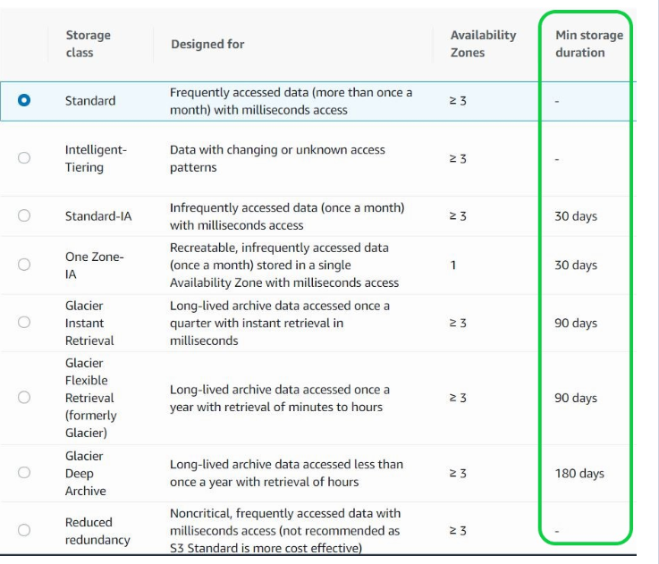

**The key differences between RDS Custom for Oracle and running Oracle DB on EC2:**

RDS Custom for Oracle:

* Managed database service with automated setup, patching, backups, and scaling
* Provides access to both the database and underlying operating system for customization
* AWS handles server maintenance while you share responsibility for OS and database maintenance
* Automates time-consuming database management tasks
* Offers more control than standard RDS but less than EC2

Oracle DB on EC2:

* Full control over database, operating system, and all resources
* You manage everything: OS patches, database software, backups, replication, scaling, networking, and security
* Similar to running Oracle on your own dedicated servers
* Complete responsibility for all configuration and maintenance tasks In summary: RDS Custom provides a middle ground - you get AWS automation for routine tasks while maintaining the ability to customize the environment. EC2 gives you complete control but requires you to manage all aspects yourself, just like an on-premises deployment.

**Amazon Lightsail** is the easiest way to get started with AWS for anyone who needs to build websites or web applications. It's a simple and cost-effective cloud platform that includes everything you need to launch your project quickly.

What Lightsail includes:

* Virtual private servers (instances)
* Container services
* Managed databases
* Content delivery network (CDN) distributions
* Load balancers
* SSD-based block storage
* Static IP addresses
* DNS management
* Resource snapshots (backups)

Key benefits:

* Simple to use - User-friendly interface that abstracts away infrastructure management complexity
* Low, predictable pricing - Single monthly price that bundles all resources
* Quick deployment - Pre-configured instances optimized for various workloads like WordPress, Drupal, and Joomla
* Managed environments - Automatically configures networking, access, and security

Lightsail is ideal for simpler workloads, quick deployments, small businesses, startups, and individuals new to AWS. It also offers Lightsail for Research for academics and researchers to create virtual computers with pre-installed research applications.

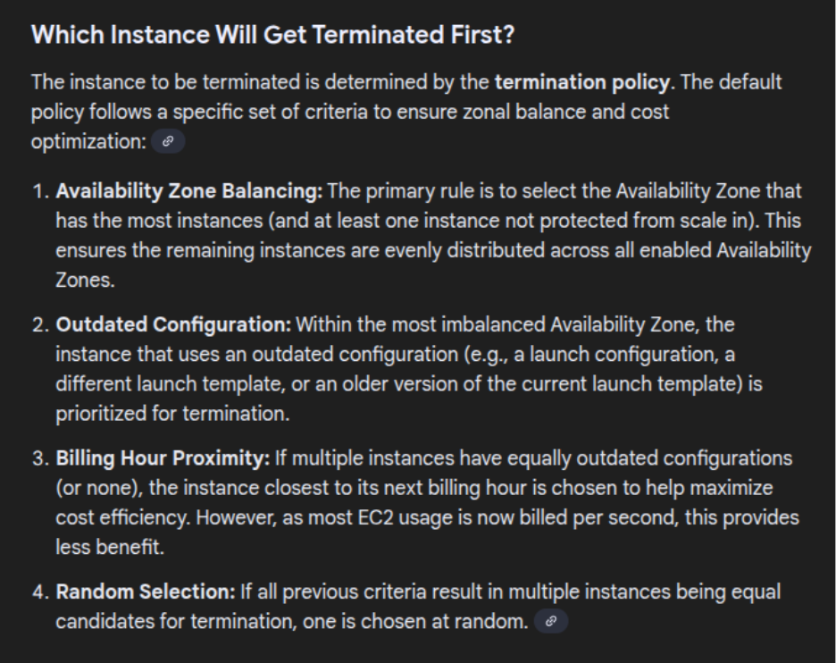

**The key differences between importing SSL/TLS certificates in ACM and IAM Certificate store are:**

AWS Certificate Manager (ACM):

* Recommended for most use cases in [supported Regions](https://docs.aws.amazon.com/general/latest/gr/acm.html)
* Provides certificate management through console or programmatically
* Supports automatic renewal reminders (daily expiration events starting 45 days prior to expiration)
* Integrates with AWS services like Application Load Balancer, CloudFront, and API Gateway
* Can be used to monitor imported third-party certificates
* Supports importing OV (organization validation) and EV (extended validation) certificates

IAM Certificate Store:

* Should only be used when you need HTTPS connections in a Region that is not [supported by ACM](https://docs.aws.amazon.com/general/latest/gr/acm.html)
* Supports deploying server certificates in all Regions
* Securely encrypts private keys and stores them in IAM SSL certificate storage
* Cannot manage certificates from the IAM Console
* Requires obtaining certificates from external providers
* Cannot upload ACM-issued certificates to IAM

**AWS License Manager** is a service that helps you manage software licenses from vendors like Microsoft, SAP, Oracle, and IBM across AWS and on-premises environments.

Key capabilities:

* Centralized license management - Track and manage licenses across multiple AWS regions and accounts within an organization
* License tracking - Automated discovery of bring-your-own-license (BYOL) usage with alerts for licensing violations
* Rule-based controls - Define rules based on licensing agreements to prevent violations (e.g., using more licenses than available)
* Compliance management - Set hard or soft limits on license consumption to reduce risk of non-compliance and penalties
* AWS Marketplace integration - Manage licenses purchased through AWS Marketplace
* Visibility and reporting - Built-in dashboards provide ongoing visibility into license usage and assist with vendor audits

**AWS Wavelength Zones** are AWS infrastructure deployments embedded within telecommunications providers' 5G networks that bring AWS compute and storage services to the edge of the network.

Key characteristics:

* Location - Logically isolated data centers within telecom providers' networks, connected back to AWS Regions via redundant, low-latency, high-throughput connections
* Purpose - Deploy workloads closer to 5G-connected users and devices for ultra-low latency applications
* Access - Only accessible via the wireless network of the partner supporting the Wavelength Zone

Available services:

* Amazon EC2 instances
* Amazon EBS volumes
* Amazon VPC subnets and carrier gateways
* Amazon EKS and ECS clusters
* Services that orchestrate with EC2, EBS, and VPC (Auto Scaling, CloudWatch, CloudTrail, CloudFormation, Application Load Balancer)

Use cases:

* Interactive live video streaming
* ML inference at the edge
* AR/VR applications
* Connected vehicles
* IoT applications requiring ultra-low latency

**NFS Protocol Services:**

**AWS Storage Services using NFS protocol:**

* Amazon Elastic File System (EFS) - Supports NFS v4.0 and v4.1
* Amazon FSx for Lustre - Supports NFS v3
* Amazon FSx for NetApp ONTAP - Supports NFS v3, v4.0, v4.1, and v4.2
* Amazon FSx for OpenZFS - Supports NFS v3, v4.0, v4.1, and v4.2

**AWS Gateway Services using NFS protocol:**

* AWS Storage Gateway (File Gateway) - Supports NFS v3 and v4.1 for accessing Amazon S3 objects as files through NFS mount points

**AWS Data Transfer Services using NFS protocol:**

* AWS DataSync - Supports NFS v3, v4.0, and v4.1 for transferring data between NFS file servers and AWS storage services (Amazon S3, Amazon EFS, Amazon FSx for Windows File Server, Amazon FSx for Lustre, Amazon FSx for OpenZFS, and Amazon FSx for NetApp ONTAP) DataSync uses an AWS-designed transfer protocol to accelerate data movement while supporting NFS as the source or destination protocol, making it ideal for migrations, data processing workflows, and ongoing data synchronization.

**SMB Protocol Services:**

**AWS Storage Services using SMB protocol:**

* Amazon FSx for Windows File Server - Supports SMB v2 and v3
* Amazon FSx for NetApp ONTAP - Supports SMB v2 and v3

**AWS Gateway Services using SMB protocol:**

* AWS Storage Gateway (File Gateway) - Supports SMB v2 and v3 for accessing Amazon S3 objects as files through SMB file shares
* AWS Storage Gateway (File Gateway for Amazon FSx) - Uses SMB protocol to communicate with Amazon FSx file systems

**AWS Data Transfer Services using SMB protocol:**

* AWS DataSync - Supports SMB v2 and v3 for transferring data between SMB file servers and AWS storage services (Amazon S3, Amazon EFS, Amazon FSx for Windows File Server, Amazon FSx for Lustre, Amazon FSx for OpenZFS, and Amazon FSx for NetApp ONTAP)

**ISCSI Protocol Services:**

**AWS Storage Services using iSCSI protocol:**

* Amazon FSx for NetApp ONTAP - Supports iSCSI for block-level storage access to logical units (LUNs)

**AWS Gateway Services using iSCSI protocol:**

* AWS Storage Gateway (Volume Gateway) - Provides iSCSI block storage volumes backed by Amazon S3 and Amazon EBS snapshots
  + Cached volumes: Store primary data in S3 with frequently accessed data cached locally
  + Stored volumes: Store primary data locally with asynchronous backups to S3
* **AWS Storage Gateway (Tape Gateway)** - Exposes virtual tape library (VTL) devices as iSCSI targets for backup applications

**Amazon DRS (Disaster Recovery Service)** is a scalable, cost-effective disaster recovery service that helps you minimize downtime and data loss by quickly recovering your applications on AWS.

Key purposes:

* Business continuity - Protect your most critical databases and applications from IT disruptions caused by natural disasters, technical failures, or human errors
* Fast recovery - Achieve recovery time objectives (RTOs) and recovery point objectives (RPOs) of minutes
* Continuous replication - Automatically replicates your source servers (physical, virtual, or cloud-based) to AWS using block-level replication

How it works:

1. Install the AWS Replication Agent on your source servers
2. DRS continuously replicates data to a staging area in your AWS account using low-cost storage
3. During a disaster or drill, launch recovery instances in minutes
4. Failback to your primary site when ready

Benefits:

* Cost-effective - Pay only for staging storage and minimal compute resources until recovery is needed
* Non-disruptive testing - Conduct drills without impacting production
* Automated recovery - Point-in-time recovery with automated conversion and orchestration
* Wide compatibility - Supports applications running on physical, virtual, or cloud infrastructure

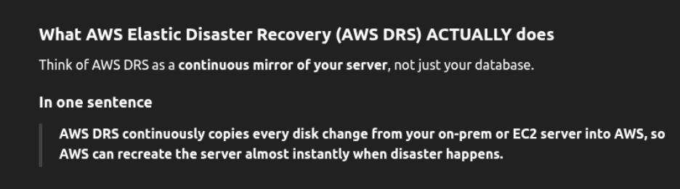

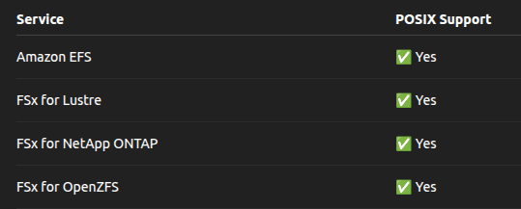

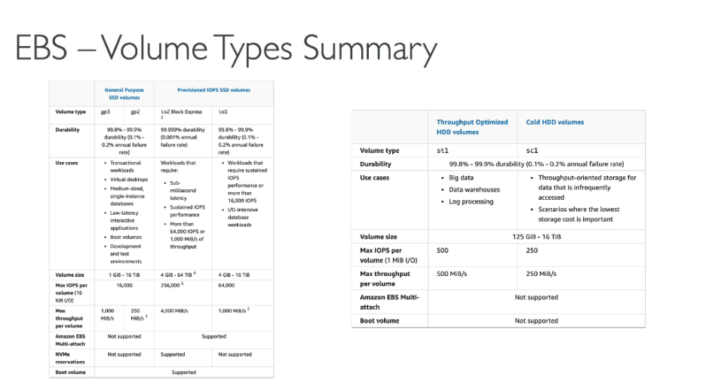

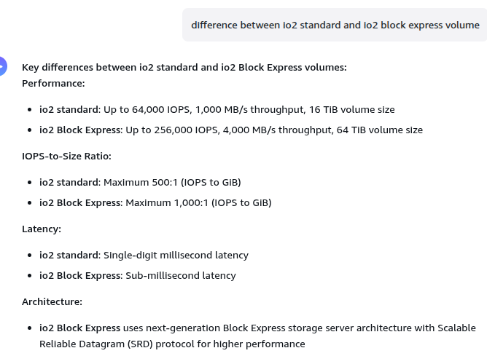

## **3️⃣ VPC Lattice (Service networking, L7)**

### **This is where most people screw up.**

### **What it REALLY is**

* **Application-level connectivity**
* **Layer 7 (HTTP/HTTPS, gRPC)**
* Service-to-service communication
* Built-in:
  + Auth
  + Service discovery
  + Traffic routing
  + Observability

### **What it is NOT**

* ❌ Not general IP routing
* ❌ Not a replacement for TGW
* ❌ Not for SSH, DB, ICMP, etc.

### **Superpower**

* Works **across VPCs and accounts**
* You don’t manage routes, CIDRs, or peering
* You publish a **service**, not a subnet

### **When to use it**

* Microservices
* ECS / EKS
* Cross-VPC app calls

**AWS Database Services Maximum Storage Capacity:**

Relational Databases:

* Amazon Aurora:
  + Latest versions: 256 TiB
  + Earlier versions: 128 TiB
  + Aurora Limitless Database: Beyond 256 TiB with horizontal scaling
* Amazon RDS:
  + MySQL, MariaDB, PostgreSQL, Oracle: 64 TiB
  + SQL Server: 16 TiB NoSQL Databases:
* Amazon DynamoDB: Unlimited storage (automatically scales)
* Amazon DocumentDB: 128 TiB per cluster
* Amazon Keyspaces (Apache Cassandra): Unlimited storage
* Amazon Neptune: 128 TiB per cluster
* Amazon Timestream: Unlimited storage (automatically scales)
* Amazon QLDB: Unlimited storage In-Memory Databases:
* Amazon ElastiCache:
  + Redis: Up to 317 GiB per node (r6gd.16xlarge)
  + Memcached: Up to 317 GiB per node
* Amazon MemoryDB for Redis: Up to 100 TiB per cluster

Analytics:

* Amazon Redshift: Petabyte-scale (depends on node type and cluster size)

**IAM Database Authentication is supported only for:**

* Amazon RDS for MySQL
* Amazon RDS for PostgreSQL
* Amazon RDS for MariaDB

Not supported for:

* Amazon RDS for Oracle
* Amazon RDS for SQL Server
* Amazon RDS for Db2

**RDS Custom does NOT support all database engines. It only supports specific engines:**

RDS Custom Supported Engines:

1. RDS Custom for Oracle:
   1. Oracle Database 19c (January 2021 RU/RUR or higher)
   2. Oracle Database 18c (January 2021 RU/RUR or higher)
   3. Oracle Database 12c (12.1 and 12.2 with January 2021 RU/RUR or higher)
2. RDS Custom for SQL Server:
   1. SQL Server 2022 (Web, Standard, Enterprise, Developer Editions)
   2. SQL Server 2019 and earlier versions

NOT Supported by RDS Custom:

* MySQL
* MariaDB
* PostgreSQL

**Route 53 Routing Policies that DO NOT Support Health Checks:**

1. Simple Routing Policy:
   1. Does not support health checks
   2. Returns all values to the client in random order
   3. Best for single resources
2. Multivalue Answer Routing Policy:
   1. While it can be associated with health checks, it's optional
   2. Returns multiple values (up to 8 healthy records)
   3. If no health check is configured, all records are returned

**Routing Policies that DO Support Health Checks:**

* Failover: Requires health checks for active-passive failover
* Weighted: Can use health checks to route traffic based on weights
* Latency-based: Can use health checks with latency routing
* Geolocation: Can use health checks with geographic routing
* Geoproximity: Can use health checks with geographic bias routing
* IP-based: Can use health checks with IP-based routing

Important Note: Route 53 doesn't check the health of the endpoint specified in the record itself (like the IP address in the Value field). Health checks are separate resources that monitor specific endpoints, and you associate them with records to influence routing decisions.

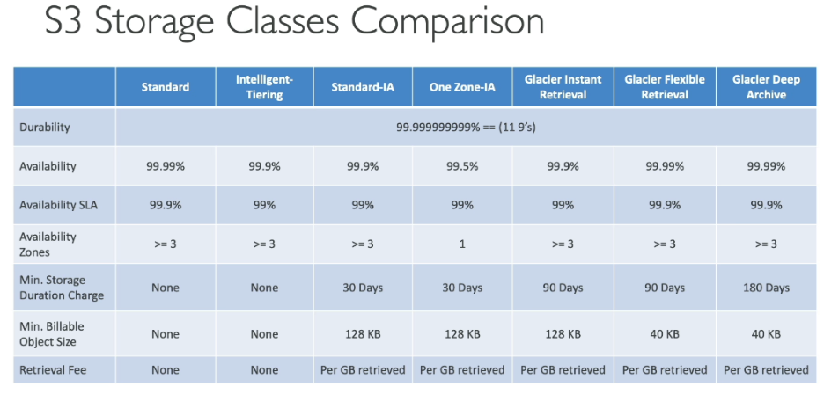

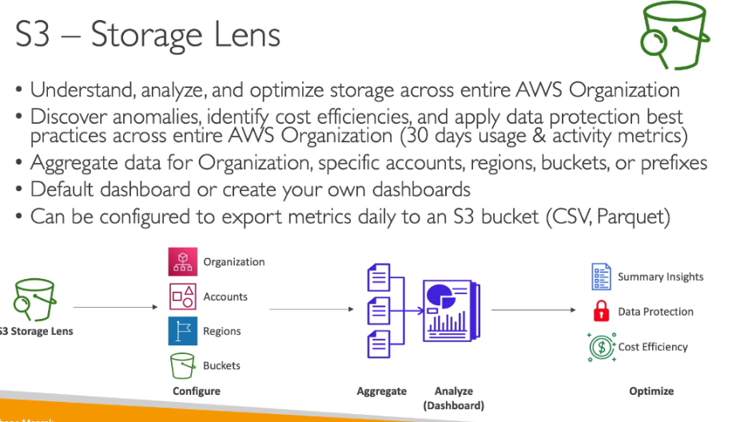

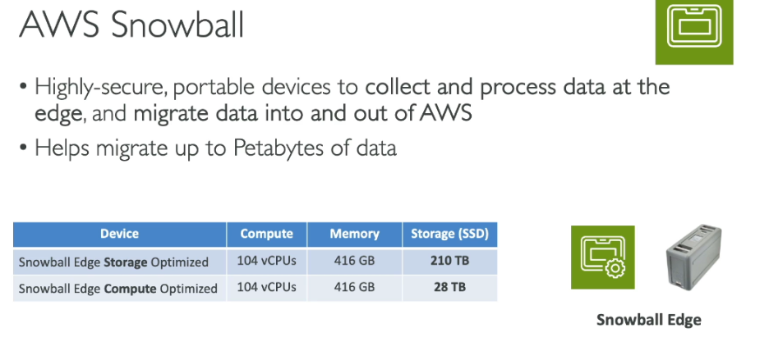

**Recommendation**:

* Lowest latency: FSx for OpenZFS (hundreds of microseconds)
* Best for databases: FSx for NetApp ONTAP (sub-millisecond with high IOPS)
* Windows workloads: FSx for Windows File Server (sub-millisecond with SSD)

**Throughput limit in SQS:**

SQS Standard Queue Throughput:

* Nearly unlimited throughput - supports a very high, nearly unlimited number of API calls per second
* No specific transaction limit per API action (SendMessage, ReceiveMessage, DeleteMessage)
* Automatically scales with demand

SQS FIFO Queue Throughput:

Without Batching:

* 300 transactions per second (TPS) per API action per partition

With Batching:

* 3,000 messages per second (300 API calls × 10 messages per batch)
* Up to 10 messages per batch with maximum 256 KB total payload

High Throughput Mode (FIFO):

* Up to 30,000 TPS with relaxed ordering within message groups
* Regional variations:
  + 9,000 TPS in US East (Ohio, N. Virginia), US West (Oregon), Europe (Ireland, Frankfurt)
  + 4,500 TPS in Asia Pacific (Mumbai, Singapore, Sydney, Tokyo)
  + 2,400 TPS in other regions

Key Difference:

* Standard: Unlimited throughput, best for high-volume applications
* FIFO: Limited throughput but guarantees message ordering and exactly-once processing

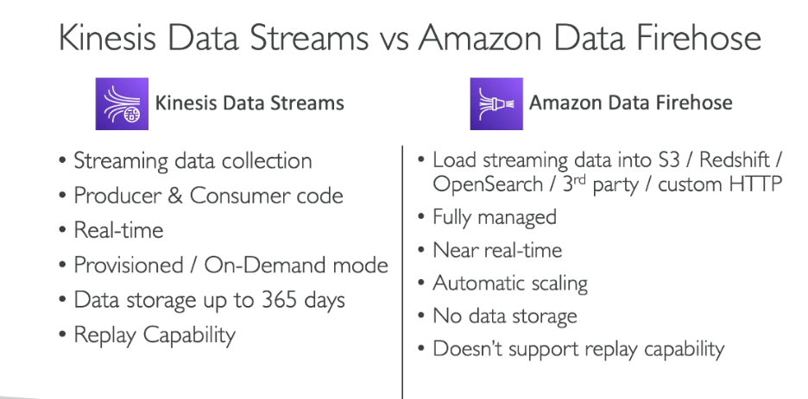

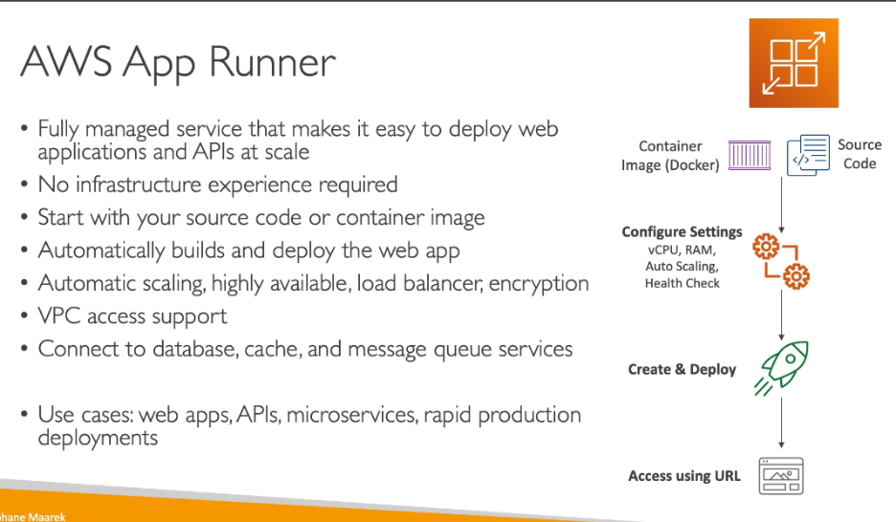

**Fully Managed Databases:**

* Amazon RDS (Relational Database Service) - supports MySQL, PostgreSQL, MariaDB, Oracle, SQL Server
* Amazon ElastiCache - for Redis and Memcached
* Amazon DocumentDB - MongoDB-compatible
* Amazon Neptune - graph database
* Amazon QLDB - ledger database

**Serverless Databases:**

* Amazon Aurora Serverless - on-demand, autoscaling relational database
* Amazon DynamoDB (On-Demand mode) - key-value NoSQL database
* Amazon Redshift Serverless - data warehouse
* Amazon Timestream - time series database for IoT and operational applications
* Amazon Keyspaces - Apache Cassandra-compatible
* Amazon Neptune Serverless - graph database

Note: Some databases like Amazon Aurora and Amazon Neptune offer both provisioned (fully managed) and serverless options, giving you flexibility based on your workload requirements.

The key distinction is that serverless databases automatically scale capacity and you pay only for actual usage, while fully managed databases require you to provision capacity upfront

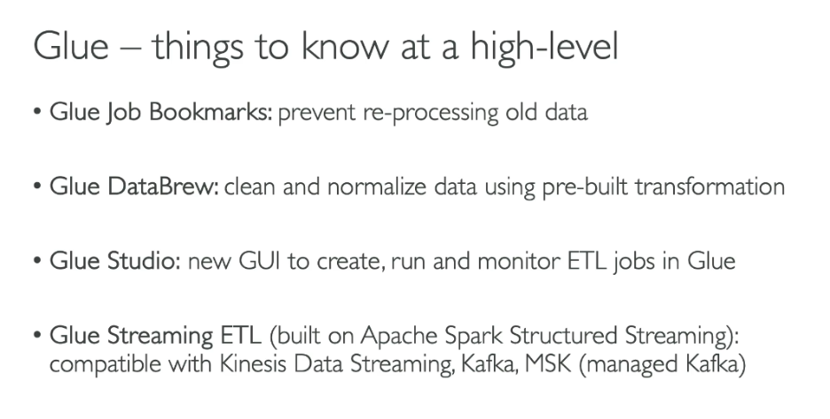

**AWS Directory Service - 3 Types Explained:**

1. AWS Managed Microsoft AD (Active Directory)

What it is: Actual Microsoft Active Directory running in AWS cloud

Example: A company migrating enterprise applications (SharePoint, SQL Server) to AWS needs full Active Directory features like Group Policy, trusts, and schema extensions.

Use cases:

* Running Active Directory-aware workloads (Microsoft applications)
* Need LDAP support for Linux applications
* Using AWS applications like Amazon WorkSpaces, WorkDocs, or WorkMail
* Require advanced AD features (trusts, schema extensions, MFA)
* Building hybrid cloud with on-premises AD integration

2. AD Connector

What it is: Proxy service that redirects authentication requests to your existing on-premises Active Directory

Example: Your company has 500 employees with existing on-premises AD accounts. You want them to access AWS applications using their current credentials without migrating AD to cloud.

Use cases:

* Already have on-premises Active Directory
* Want users to sign in to AWS services with existing AD credentials
* Need to join EC2 instances to existing AD domain
* Don't want to replicate or sync AD data to cloud
* Cost-effective option when you don't need AD in the cloud

3. Simple AD

What it is: Standalone, Samba 4-based directory service with basic AD compatibility

Example: A startup needs basic user authentication for 50 employees using Amazon WorkSpaces but doesn't require full Microsoft AD features.

Use cases:

* Small organizations (<5,000 users)
* Need basic LDAP functionality
* Using simple AWS applications (WorkSpaces, WorkDocs)
* Don't need advanced AD features
* Cost-conscious and want the most affordable option
* No existing on-premises directory infrastructure

Quick Decision Guide:

* Managed Microsoft AD → Need full AD features or enterprise applications
* AD Connector → Already have on-premises AD, just need AWS access
* Simple AD → Small scale, basic needs, budget-friendly

**SSM Parameter store:**

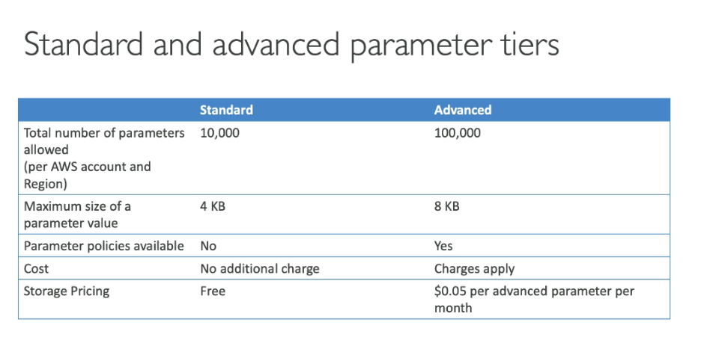

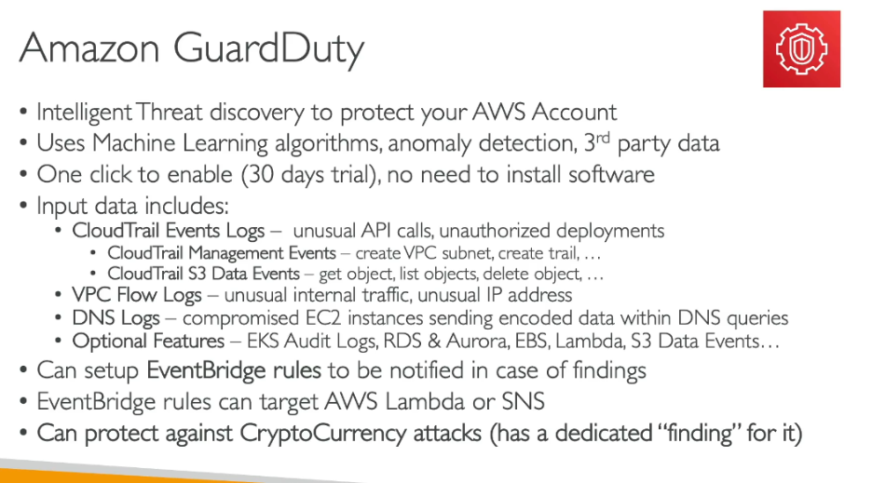

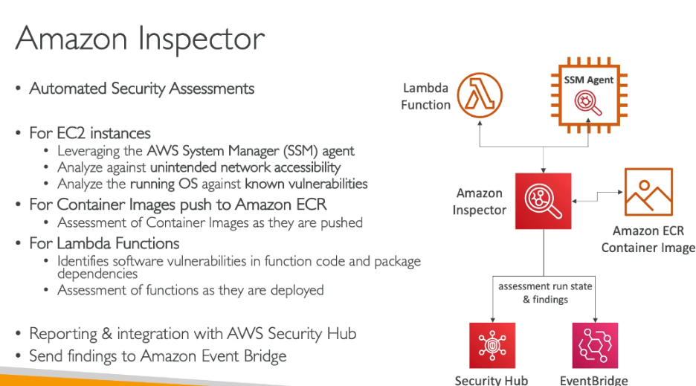

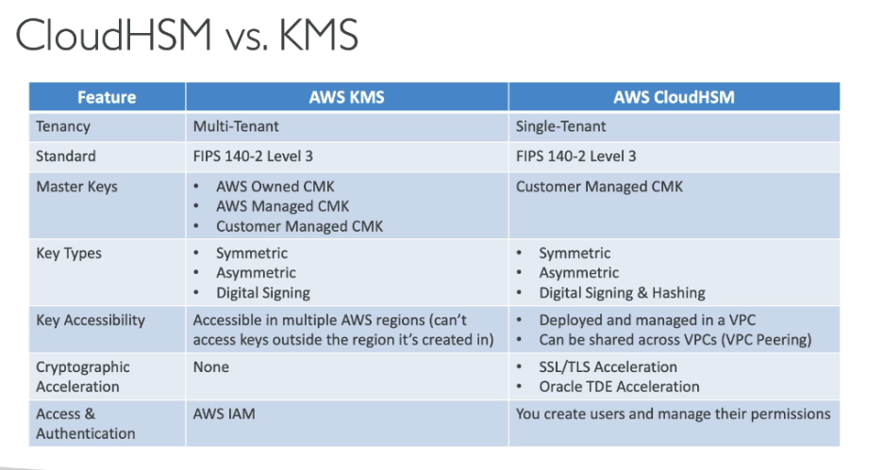

|  |  |  |
| --- | --- | --- |
| **Snow Device** | **Usable Storage** | **Typical Use** |
| Snowcone | ~8 TB | Small / edge / remote |
| Snowball Edge (Storage Optimized) | ~80 TB | Large data transfer |
| Snowball Edge (Compute Optimized) | ~42 TB | Data + compute |
| Snowmobile | Up to 100 PB | Data center migration |

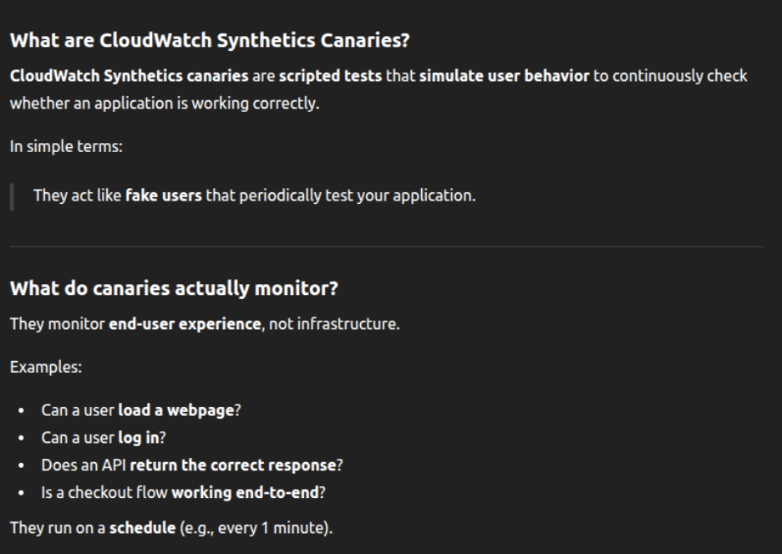

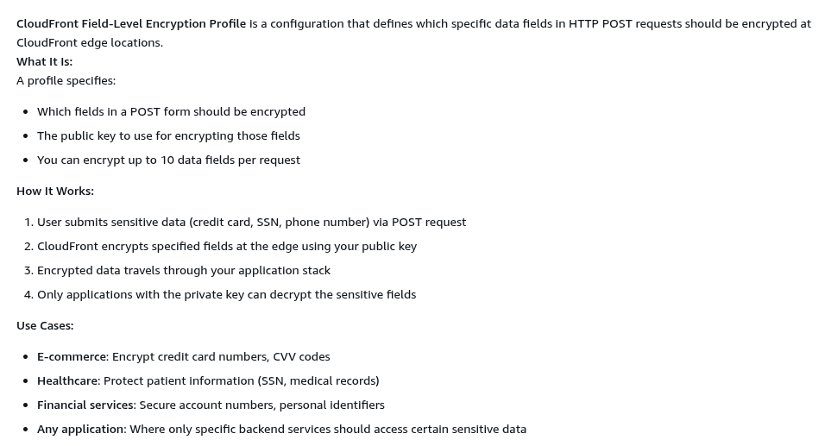

**Amazon AppFlow vs AWS AppSync:**

Amazon AppFlow:

* What it is: Fully managed integration service for transferring data between SaaS applications and AWS services
* Purpose: Data integration and ETL (Extract, Transform, Load)
* Direction: Bidirectional data transfer
* Focus: Moving data between systems without writing code

Key Features:

* Connects SaaS apps (Salesforce, ServiceNow, Slack, SAP) to AWS services (S3, Redshift)
* Automated data flows on-demand, scheduled, or event-triggered
* Data transformation and filtering capabilities
* No code required for integration

Use Cases:

* Syncing Salesforce contacts to Amazon Redshift for analytics
* Ingesting support tickets from Zendesk to S3
* Aggregating data from multiple SaaS sources
* Keeping data synchronized across applications

AWS AppSync:

* What it is: Fully managed GraphQL service for building real-time APIs
* Purpose: API development and real-time data synchronization
* Direction: Client-server communication
* Focus: Building scalable APIs with real-time capabilities

Key Features:

* GraphQL API creation and management
* Real-time data updates via subscriptions
* Offline data synchronization for mobile apps
* Integrates with DynamoDB, Lambda, RDS, HTTP endpoints

Use Cases:

* Building mobile/web applications with real-time features
* Chat applications requiring instant updates
* Collaborative apps with offline sync
* Creating unified APIs across multiple data sources

Key Difference:

* AppFlow = Data integration between SaaS and AWS (backend-to-backend)
* AppSync = API layer for applications (client-to-backend) MCQ Tip: AppFlow = SaaS integration, AppSync = GraphQL APIs with real-time capabilities.

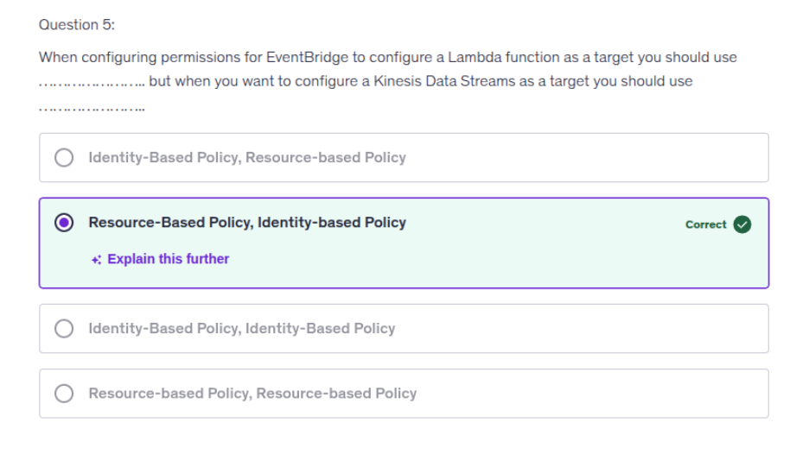

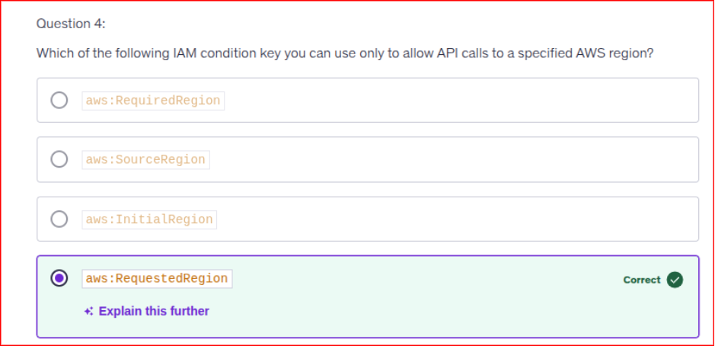

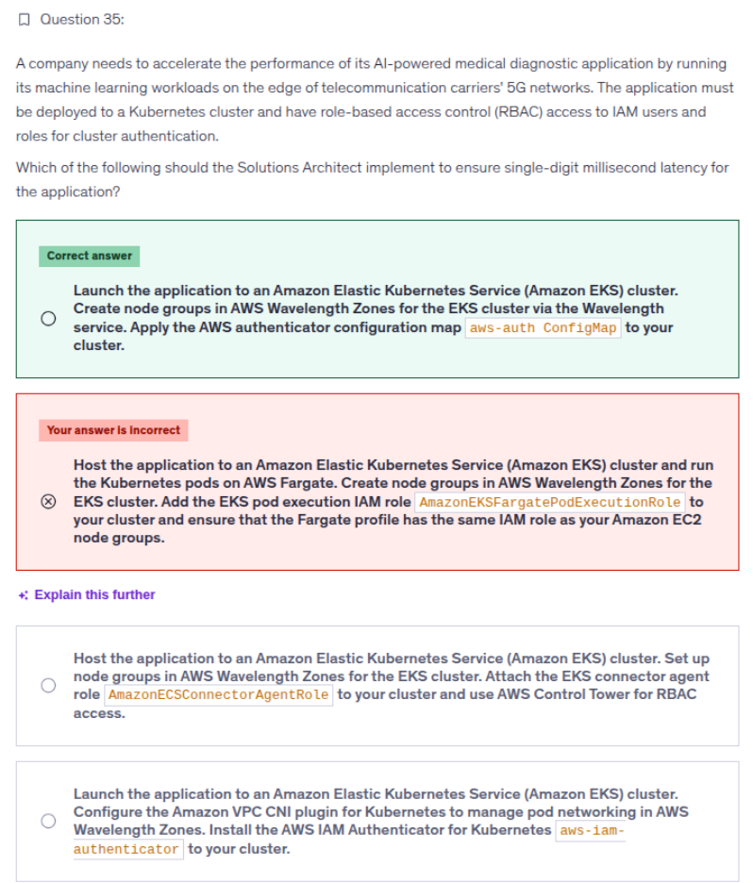

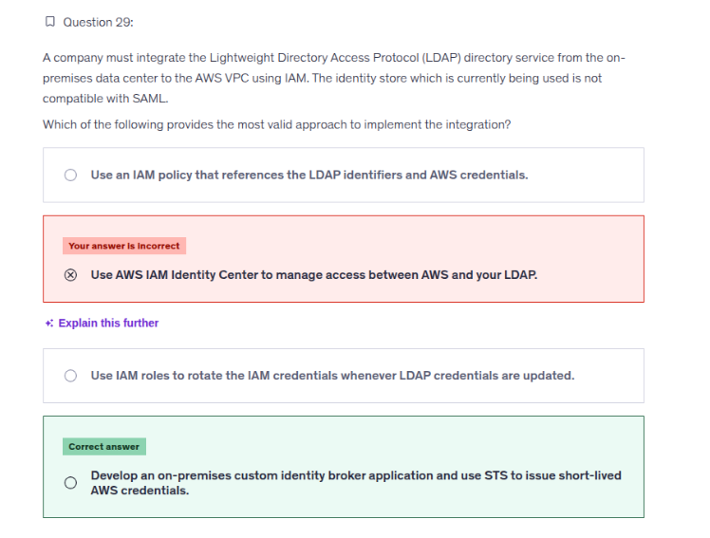

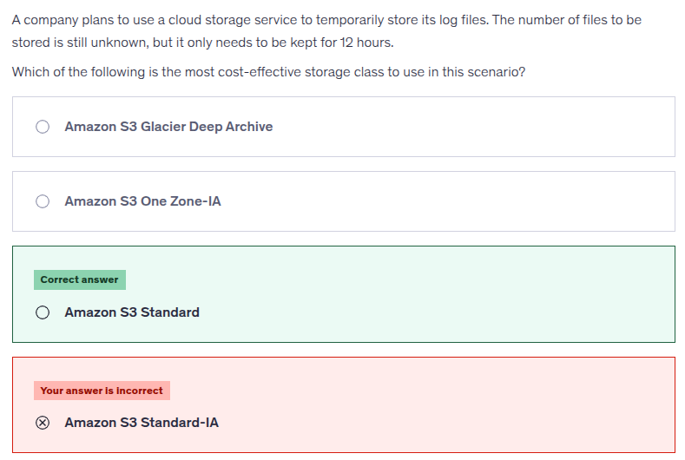

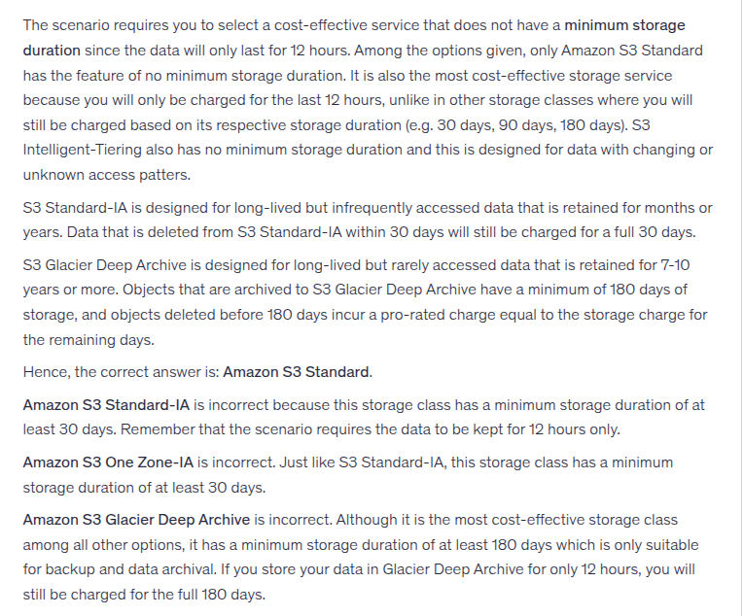

Quiz-2:

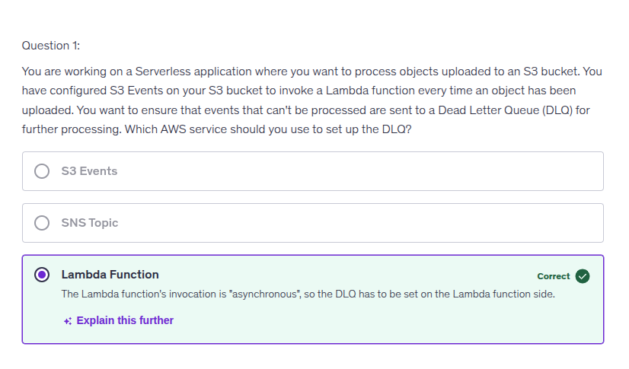

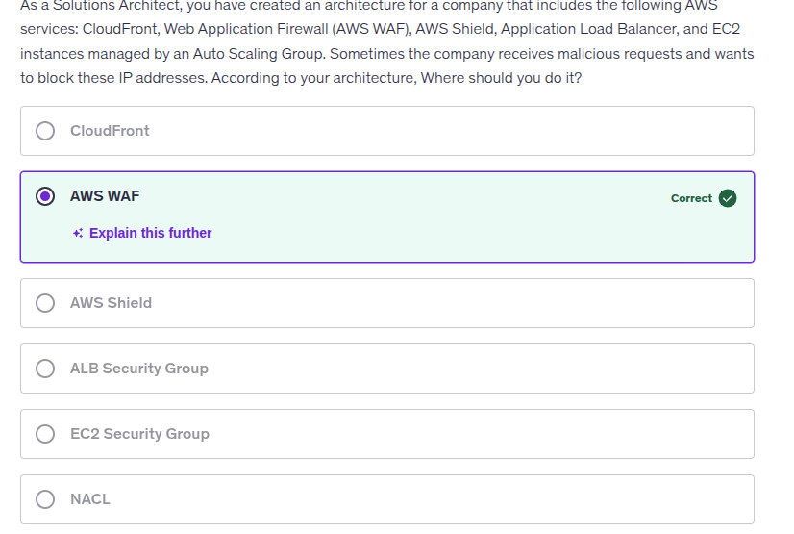

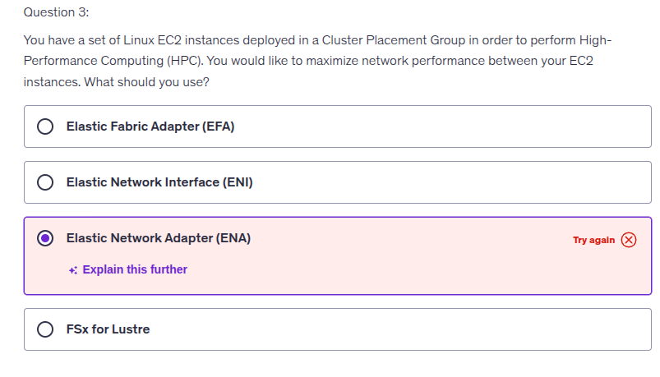

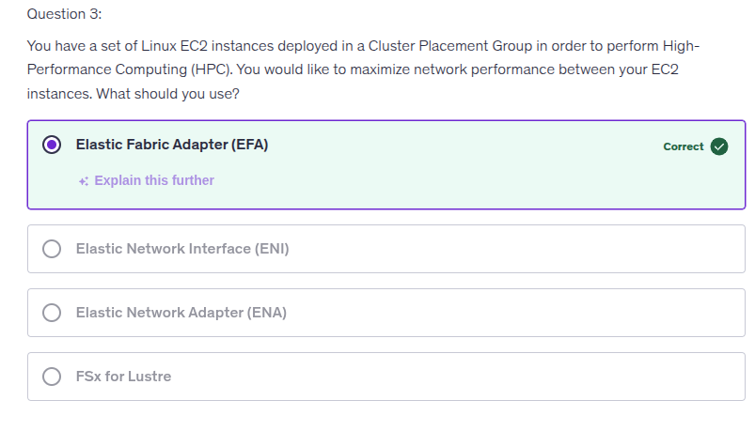

The Elastic Fabric Adapter (EFA) is the correct choice because it provides high throughput and low latency for applications requiring high-performance computing, aligning with the objective of understanding advanced networking capabilities in cloud environments. This technology enhances the efficiency of distributed applications, which is essential for modern cloud infrastructures.

Quiz-1:

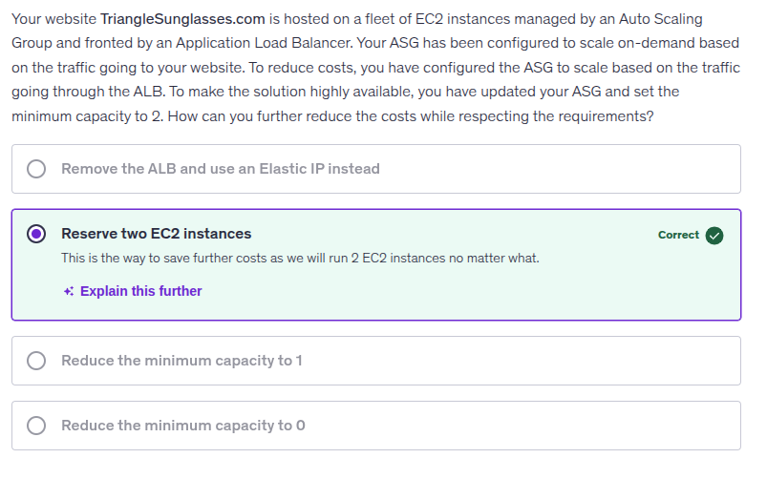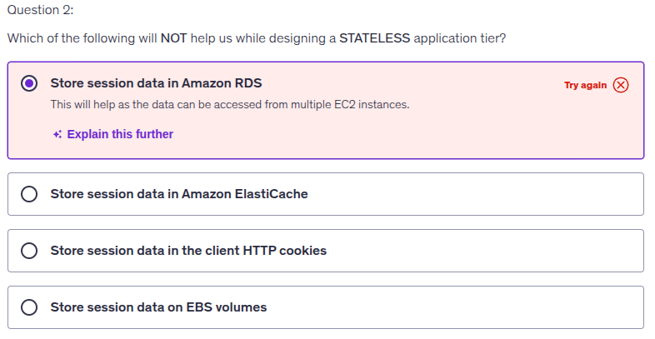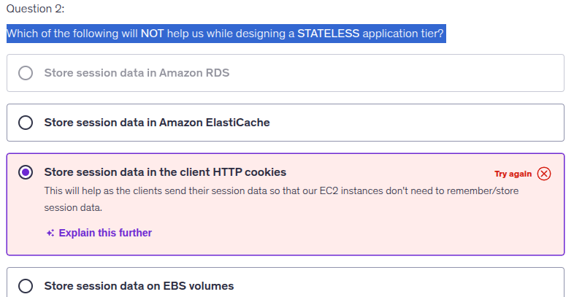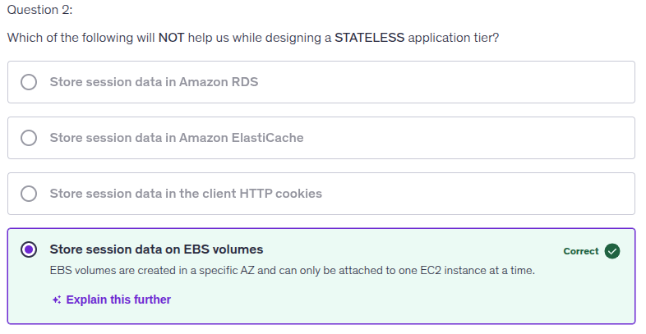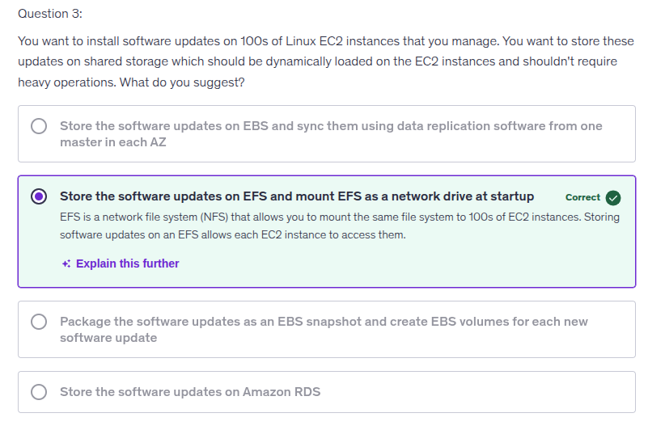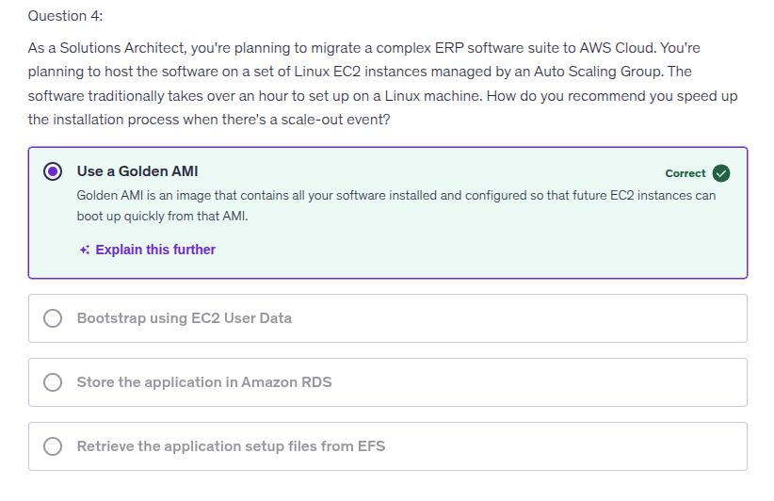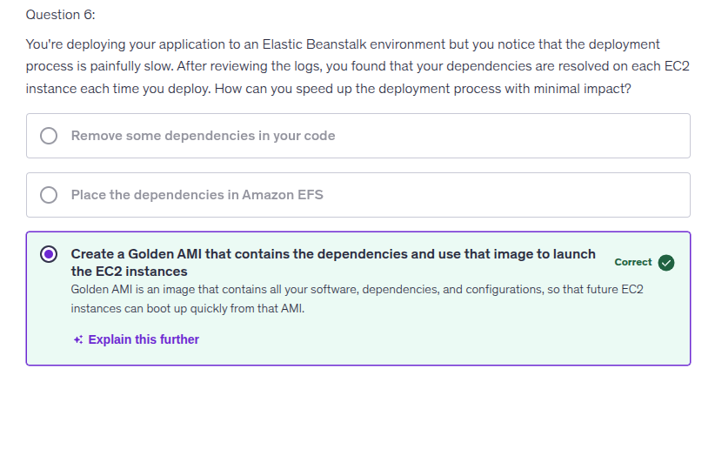

1. Egress only Internet gateway is for IPV6 only. If the instances in the private subnet are using IPV6 and needs internet access then they cant use NAT Gateway because NAT Gateway is for IPV4 only, they need to use Egress only internet gateway.